Identities and the Media: Old Age in Film and Television
Rob Miller | Friday September 12, 2014
Categories: A Level, AQA A Level, AQA A2, Collective Identity, Representation of Age, Key Concepts, Representation & Stereotyping, Hot Entries, Theory, Queer Theory, Representation Theory
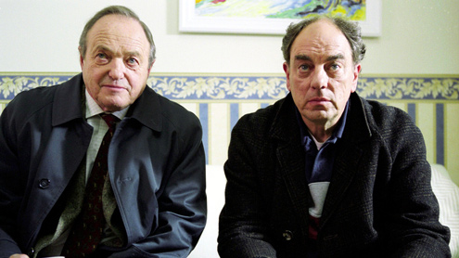click on image to enlarge
Identity and age is a broad topic for study with youth identity a much debated and analysed area focussing on Gauntlett’s prosumer, interactivity using web 2.0 and the representation of the self through social media platforms, creating online identities and user generated content. Cultural identities of old age however have become a marginalised area of representation study and potentially in the media are still victim to hegemonic cultural stereotyping more than most - if stereotypes are challenged it is frequently only through ironic humour as in the July 2014 BT Infinity television commercial where audiences find themselves surprised that Simon’s grandfather can competently use a tablet as digital technology.
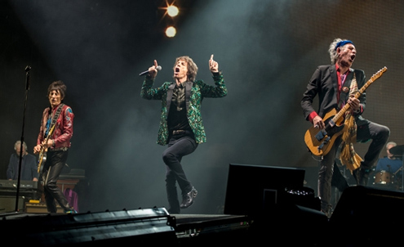
Pluralistic cultural identities of age seem to be restricted to hyper real examples as in the Rolling Stones, all of whom are grandfathers with Mick Jagger in 2014 a great grandfather. Their appearance on the main stage at the Glastonbury Music Festival in 2013 anchoredtheir iconic status and longevity and maintained their aspirational representation to male audiences in terms of their age. The cultural stereotype of old age invariably hasconnotations of vulnerability, helplessness and undesirability with television news frequenting reinforcing and circulating this representation with news stories about care homes, old people in need of rescuing because of floods and a particular favourite, old people driving up the wrong side of the motorway. Audiences are conditioned into expecting these types of identities because they have become so common and normalisedthat anything that deviates from this stereotype almost has the status of a niche or novelty text. In ‘The Politics of Childhood’, Martin Hoyles discusses how children used to have no socio economic value in society but now, the concept of the teenage dot.com entrepreneur is far more acceptable than any pluralistic representation of older age. Ironically however, one of the most powerful, and more familiar older men in the media is the 83 year old founder, Chairman and CEO of one of the world’s largest media companies – the News Corporation.
Historically, and in more traditional societies the cultural identity of old age would be fixed but now, up to a point, older people have a greater role in constructing and negotiating a role and an identity for themselves. Below we see a poster for the 2013 action thrillerEscape Plan starring Sylvester Stallone, aged 68 and Arnold Schwarzenegger, aged 67. Both men utilise their secondary persona as historical action heroes from Rocky, Ramboand Terminator films to break out of maximum-security prisons and ensure audiencesidentify with their representation as action heroes. Here, the identities of both men are dominant and in the world of mainstream Hollywood film there are still a narrow set of identities that commercially appeal to mass audiences. As David Gauntlett argues they “offer narrow interpretations of certain roles and lifestyles”. Here clearly the dominant role, bringing in an ideological construct is the physically strong, determined and controllingpatriarch who still is revered and respected.
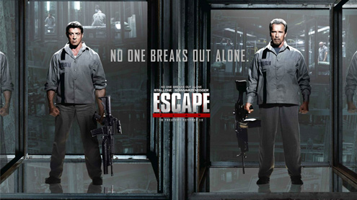click on image to enlarge
Audiences of media texts have a heightened role to play in the construction of identity – using Stuart Hall’s basic, but helpful framework audiences share in the dominant, traditional preferred meaning in relation to the representation of age but here, also gender. It is less common to see a dominant, older female identity in Hollywood film and certainly even less common to see a sexualised older female representation. Stallone and Schwarzenegger, using Blumler and Katz’ uses and gratifications framework still present audiences with an identity that they can identify with but also as a form of diversion or escapism. The characters are framed as aspirational for male audiences but also, up to a point for the female gaze for female audiences. Marxists film critics would argue that these fixed identities suit the needs of big distributors like 21st Century Fox, Universal, Disney, Paramount, Sony and Warner Bros in their commercial ability to exploit an identity and at the same time, not really positively promoting the cultural identity of old age. It is the uncommon aspect of a film like Escape Plan, coupled with the commercial priorities that prevents perhaps both identities being categorised as pluralistic.
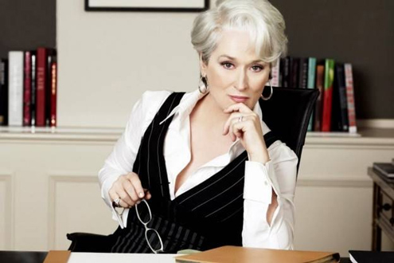
Meryl Streep, at 65 commands a gravitas but also a strong screen presence playing dynamic, physically and intellectually controlling characters such as Margaret Thatcher inThe Iron Lady in 2011 but also as Miranda Priestly in The Devil Wears Prada (2006) – a powerful and controlling, but crucially sexualised fashion magazine editor who uses her representation to dominate both women and men. Applying Angela McRobbie’s theory, Streep is framed as an older post feminist icon as both exhibiting male and female stereotypes to create a dominant identity. McRobbie has written widely on sexual identity but tends to focus on the negative effects on young women of representations that are narrowly based on sex, appearance and relationships. In The Devil Wears Prada, Streep challenges the cultural stereotype that older women tend less to be cast in overtly sexualised roles and constructs a pluralistic identity. Helen Mirren, at 69 has constructed similar identities both on and off screen and has maintained a sexual siren representation through historical texts such as Caligula (1979) through to Calendar Girls (2003) and The Debt (2011). Male audiences’ perception of Helen Mirren is still filtered through notions of the male gaze which has been maintained in other media, including interviews.
Mirren challenges the sociological construct of older female sexuality being symbolically annihilated and marginalised as a result of simply the age of the media personality – slightly older contemporaries of Mirren such as Dame Maggie Smith and Dame Judi Dench have strong screen personas as older actresses but their identities have been more fixed, playing roles that require a degree of gravitas, from controlling James Bond to domineering roles as the Dowager in Downton Abbey. Again, this would reference the notion of mainstream media and the exploitation of an identity for purposes of audience identification but also for commercial success. Both actresses have a history of playing determined, controlling characters who generate fear and respect on screen. This would link with David Buckingham’s theory that identity is a unique marker of a person in that audiences understand that both have been subject to generic typecasting, and that this in turn suggest a more fixed identity but pluralistic on the level that they are dominant in their roles.
Sir Ian McKellan’s career has crossed over film and television and spans nearly six decades. His own off stage, pluralistic identity has been determined by active LGBT campaigning after ‘coming out’ and declaring his homosexuality on the radio in 1988. As a very outspoken critic of the government and negative public attitudes to homosexuality, he once visited the then Home Secretary, Michael Howard in 2003 to lobby against a Section 28 local government bill which stated that a local authority: “shall not intentionally promote homosexuality or publish material with the intention of promoting homosexuality”. Howard refused to change his position but asked for McKellan’s autograph for his children to which McKellen obliged by writing “Fuck off, I’m gay” on a piece of paper. In 2008 he caused a major stir in Singapore when he was invited to do an interview on a morning show and shocked the interviewer leading to the show being immediately cut by asking if they could recommend him a gay bar. Like Victor Meldrew in the BBC sitcom One Foot in the Grave, McKellan has constantly challenged the expected passive identity for someone of his senior years by railing against the dominant ideology. One Foot in the Grave however, as a mainstream text scheduled prime time on BBC1 conformed to many cultural stereotypesof age by representing Meldrew as frail, limited in what he can now do, as retired and as resentful of his years and the changing world of technology around him.
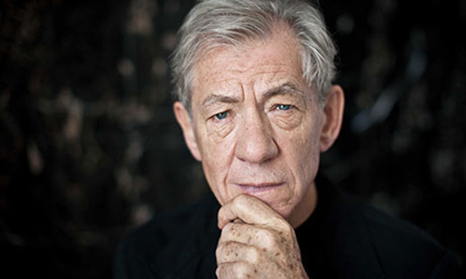
McKellan’s excursion into sitcom culture recently explored more fully a range of wider, morediverse identities in Vicious (ITV1) which starred him and Derek Jacobi as an elderly gay couple who have been together for 48 years but endure a love/hate relationship. As an older, gay couple they celebrated diversity by challenging the traditional sitcom framework that commonly favours ‘safe’ representations that acknowledge a wider, more traditionalcollective identity. Predictably however, the show received a lukewarm reception and from mainstream media was overtly criticised. Brian Sewell, art critic of the London Evening Standard described the series as a “spiteful parody that could not have been nastier had it been devised and written by a malevolent and recriminatory homosexual”. Sewell’s reaction epitomised the mainstream media’s role and influence in the construction of identities or rather, in the case of Vicious to lampoon mainstream sitcom culture by providing viable, alternative identities. Interestingly though, many of Mckellan’s other notable performances have constructed powerful, dominant masculine identities fromRichard III through to Magneto in X-Men and Gandalf in The Hobbit and Lord of the Ringstrilogy.
Within these roles playing elder, respected figures McKellan’s characters have brought with him the stereotype of wisdom and knowledge that mainstream culture suggests comes with age. Christopher Lee, now 92 has played comparable roles which also suggest a form of seriousness that only the passage of time can bring – these have included Saruman in Lord of the Rings as the black arts protagonist to Mckellan’s Gandalf the White, two old men fighting it out in a fictional, fantasy based diegesis. Mckellan’s commercial roles suggest a diversity and range of ability but also evidence a diverse range of identities that he has constructed on screen for an audience. Lord of the Rings and The Hobbit embrace commercialism and as such, are very different from roles in sitcoms like Vicious whereJudith Butler’s interpretation of queer theory can apply. One reason perhaps for the lack of critical and commercial success to the programme was that it attempted to understand differences in sexual identity and destabilized the cultural norm by representing a homosexual relationship between two old men which had been ‘happily’ running its course for nearly five decades. Queer theory suggests certain sexual preferences are normal and that anything else is deviant and in Vicious, heterosexual relationships are satirised. Cam and Mitch are a middle aged gay couple in Modern Family but are not shown as a couple that much while the older Mckellan and Jacobi characters are central protagonists, a challenge for the mainstream broadcast channel ITV1.
Cultural identities of old age are notable less diverse across a range of media but are more prevalent on Reality TV and in particular, Entertainment platforms – Bruce Forsyth remains an iconic showman, entertainer, singer, dancer and recently retired presenter of Strictly Come Dancing at the age of 86 while Tony Bennett still tours at 88. These older statesmen of the entertainment industry however conform to cultural stereotypes as promoting traditional, patriarchal ideology. The Pythons have just completed a series of shows at the O2 in July 2014, marking the end of their collaboration together again. Eric Idle and John Cleese both have Twitter accounts that are undoubtedly run by a management or a PR company but create the myth of interpersonal interactivity with their fans using social media, not normally associated with the older generation. Both have used Twitter to maintain but also extend their identity to their fans through a range of interconnections that are often audience led. This creates debates about whether web 2.0 fulfils democratic and pluralistic ideals by allowing the creation of original identities to suit the needs of an ageing celebrity or by just conforming to, and recreating identities that have already been consumed in the mainstream media. Either way, both Pythons challenge stereotypical notions by engaging in this kind of interaction.
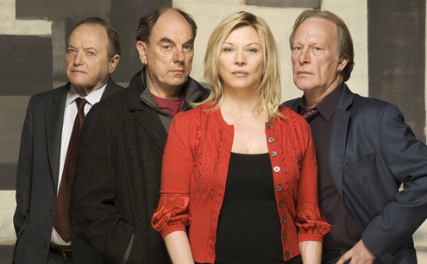click on image to enlarge
New Tricks also suggests that mainstream media representations are beginning to be challenged and audiences, as a result of progressive social change are more receptive to more diverse representations – as a Police procedural/comedy hybrid crime drama its narrative focuses on older, retired Police Officers who are brought in to follow up on unsolved crimes from years past. Denis Waterman, James Bolam, Alun Armstrong, Amanda Redman (replaced by Tamzin Outhwaite in 2013) and now Nicholas Lyndhurst investigate in a programme that quietly amasses high ratings and achieves commercial success. The basic narrative premise of the title that “you can’t teach an old dog new tricks’ suggestspluralism but within a hegemonic construct and is this regard, a key audience appeal is nostalgia. The primary audience demographic suggests 45-65, male/female who see the characters as aspirational. This should not be immediately dismissed as pandering to the historicism of the audience as in each episode the characters are seem to actively engage in 21st century technology and utilise available technology to help them solve the crime. The Denis Waterman character however moans like Victor Meldrew and on one level, atraditional collective identity of old age is established through its dominant representations.
James Bolam currently plays an interesting role on CBeebies in pre school comedy drama series called Grandpa in My Pocket. Grandpa (James Bolam) has a magical shrinking cap which enables him to become 5 inches tall, run very fast and experience a range of adventures.
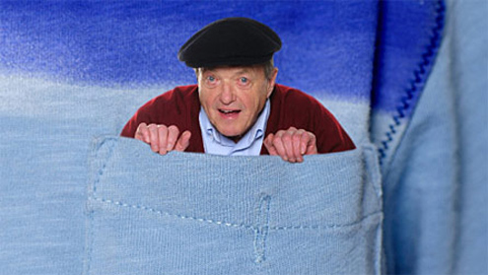
It subverts the grandchildren/grandparent relationship by representing a traditional Grandpa as physically active, busy but still in terms of the perception of others, conforming to a stereotype. Sometimes they think he has gone for a nap while really he is running under floorboards chasing a hamster or bringing a toy robot back to life. The programme addresses potential issues of passive consumption by vulnerable audiences (children) by challenging the normalised cultural identity of a grandparent by showing resistance to hegemonic categorisation which frequently leads to the marginalisation of the old as a social group. With pre school children as a social group the media, or specifically film and television are sites of cultural information that potentially influence the construction of one’s own identity.
Television as a media platform has also facilitated the re-launch of the career of food writer Mary Berry at the age of 79 and other older media celebrities. After initially appearing as a judge alongside baker Paul Hollywood in the BBC Two Reality show, The Great British Bake Off she has a new solo show called Mary Berry Cooks. In March 2013 she was listed as one of the best dressed over 50s by The Guardian, eventually coming second to Helen Mirren. Television and Film have come a long way since identities established in programmes like Last of the Summer Wine but only more recently have these identities entered mainstream media – it is worth remembering the commercial value of a stereotypical representation and as Andy Medhurst would argue, stereotyping is shorthand for identification.

Identities and the Media: British National Identity
Rob Miller | Friday September 12, 2014
Categories: A Level, AQA A Level, AQA A2, Collective Identity, National Identity, Key Concepts,Ideology, Representation & Stereotyping, Hot Entries, Theory, Representation Theory
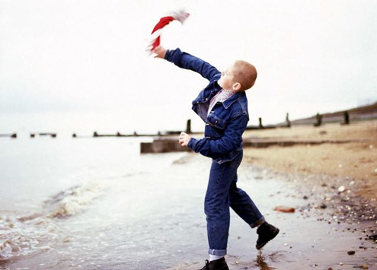
With AQA’s new ‘Identities’ topic, it is worth stressing from the outset the similarities and differences with Representations in the Media – the use of representation is a process for constructing identity and in this regard, a representation or representations can lead to acollective identity. This resource attempts to explore the concepts of ‘Britishness’ or British National Identity by studying a range of media texts, across a number of media platformsbut also exploring audience consumption. It is important to reference the impact of technology on Identities but moving forward, also the ideological functions of identity e.g. from multicultural British National Identity to patriotic sporting identity to nationalism and other extreme ideological viewpoints.
Within this notion of identity it is also worth referencing self-representation and the role of the individual in society – someone who rejects national identity for example, someone who is marginalised or who marginalises themself, someone who embraces a European identity in favour of a British identity or someone who is in favour of Scottish independence and devolution, contemporary as of writing in early September. This is reflected by David Gauntlett’s much quoted sound bite: “Identity is complicated, everyone’s got one” suggesting a unified British identity in many ways can be seen as abstract. Britain is adiverse and pluralistic country and this is reflected by media representations; as Jill Nelmes suggested in ‘An Introduction to Film Studies’: “it is impossible to talk about national identity without referencing regional identities, films that explores a range of disparate identities, genres and movements”.
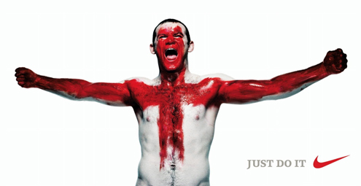click on image to enlarge
Audiences of media texts have a heightened role to play in the construction of identity – in the Daily Mail, using Stuart Hall’s basic, but helpful framework audiences share in the dominant, traditional preferred meaning in relation to the representation of British Identityencoded within the editorial. Headlines below reflect a hegemonic national identity that chooses to directly link multiculturalism with marginalised notions of ‘the other’, refusing to accept that the concept of Britishness is now a fluid, fragmented dialogue that is open to socio-cultural factors, not just historical and geographical. In the above two images we see a screenshot of Shaun from the independent British film, This is England (2006) throwing the flag of England, the St. George Cross into the sea symbolising him turning his back on racism while Wayne Rooney, from the same year is painted red in the shape of the St. George Cross promoting England’s football team at the 2006 World Cup.
Both images are controversial in different ways but fundamentally reflect an appropriation of national identity for different reasons – the St. George Cross has been used by extreme right wing groups like the National Front and BNP over the years to represent a racist, extreme right wing political ideology while Rooney’s bloody red cross has a range of negative connotations. The biggest advertising execution was a 60ft poster alongside the M4 in west London which many critics found ‘war like’ and jingoistic, harping back to WWII. Others found it offensive as he is posing in the shape of a cross while others looked more closely at the national identity aspect suggesting it was aggressive with connotations of the bloody crusades; either way reflecting problematic identity.
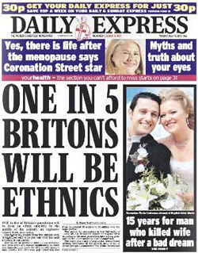
Arrivals to the UK now take an oath of allegiance as new British Citizens to‘faithfully support the British monarch’ and make a pledge at a Citizenship Ceremony promising ‘loyalty to the United Kingdom, respect for its rights and freedoms, to uphold its democratic values, observe its laws faithfully and to fulfill the duties and obligations of a British citizen’. One academic stated recently that “teaching Britishness is impossible because Britishness does not exist” which may or may not be correct dependent on your ideological perspective – left wing/liberal pluralism, UKIP nationalism, Welsh/Scottish nationalism or the concept of metro centrism where London is seen as the aspirational identity hub of the UK. Gordon Brown tried to lessen the collateral damage and shock waves the election of a Scottish Prime Minister may have had by saying at a conference on Britishness in 2006: “Britain has something to say to the rest of the world about the values of freedom and democracy and the dignity of the people you stand up for” while in 2014 he is urging the Scots to reject independence if they want to avoid massive NHS cuts. In the 1996 film Trainspotting, Renton gives a voice to Scots who wish to pull away from what they feel is the oppressive, controlling English parliament: “It’s shite being Scottish! We’re the lowest of the low. The scum of the f***ing earth…..Some hate the English. I don’t. They’re just w***ers. We, on the other hand are colonized by w***ers”.
Andy Medhurst and Tessa Perkins would argue that stereotyping is shorthand for identification – media representations continually reinforce and circulate stereotypes including an August 2014 advert for the ‘Better Together’ campaign which has been accused of portraying Scottish women as ‘daft ditherers’. It features and actress complaining about the constant referendum coverage and being hassled to make a decision by her partner, without understanding the magnitude of the decision she ‘has’ to make. The narrative suggests that women who are still making up their minds don’t understand enough about the issues:
Rab C. Nesbit put Scottish national identity back into the stone ages in the 1980s while the TV Drama Monarch of the Glen uses the dramatic backdrops of the highlands and islands to represent a more exclusive, and remote Scottish national identity.
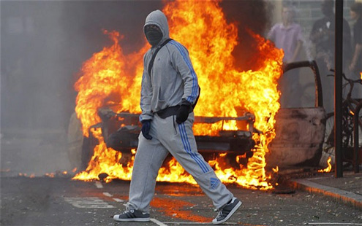
Charlie Brooker - writer, cultural commentator, journalist and comedian admits to embracing a negativity about Britishness by stating “Misanthropy….it’s not a personality flaw, it’s a skill” and regularly cites American comedian Bill Hicks as one of his influences quoting his immortal line “The Human Race is a virus with shoes”. It stereotypically is in vogue in Britain to be negative, to criticise but not to offer any positive suggestions for alternative approaches, to believe there is nothing we can do and we must just stand in queues and accept our fate: this is what many see as the self representation of British national identity, a self deprecating mirror image. George Gerbner’s cultivation theory broadly speaking suggests that too much information we know about the world comes from television - Channel 4 recently ran an interactive current affairs programme called ‘Selling off Britain’ promoting the ‘Broken Britain’ moral panic which appears and reappears in the media at political crisis points - to give it authenticity a Channel 4 news presenter anchored the show in front of a studio audience who were asked to go interactive and vote on questions like: “What percentage of you would sell off the motorways of Britain to raise money?” or “Who would sell Birmingham to raise money?” and “Should we sell off the nuclear missile programme?” with the implication that Britain needs to urgently raise money to survive.
Each asset stripping topic voted on was preceded by a pseudo discussion with Edwina Currie chipping in a part of the studio audience, lurching from one comment to another at the same time intercut with video footage of the relevant topic on sale and talking heads. The footage included cars on a motorway, Top Gear presenters being interviewed and Defence Chiefs stating the strategic benefits of the Trident Missile Programme. The format of the show was more like a Reality TV programme. Interactive links to the Channel 4 website allowed viewers to research the most valuable assets in their area, it was all a bit like a closing down sale but crucially explored again a common self realisation. Identity is the way we see ourselves and the way different groups in society see us. We have acultural identity, as reflected through film, television, social media, print media etc. in that we ‘belong’ to particular cultures and groups. Audiences’ perception of British national identity is mediated through a range of diverse representations and the concept ofaudience identification places the audience close to ‘belonging’ to a specific representation. In ‘The Time of Tribes’, Michel Maffesoli argues that unified national identity is mythical, in part due the to geographical and technological diversification of countries like the UK who have distinct regional representations.
Hegemony is where representation tends to be more traditional, historically stereotypical but crucially is reinforced and re-presented back to audiences as ‘common sense’ reflecting a shared national identity. The royal family is a classic example of a hegemonic construct underpinning British national identity that is reinforced not just by magazines like OK! but also by newspapers like The Daily Mail and The Sun. The Daily Mail mediates traditional, old fashioned, back to basics representations that suggest Britain is still the same type of nation with the same demographic make-up of 60 years ago. As identified earlier, multiculturalism is reluctantly acknowledged by the newspaper but it sees it as divisive and undermining – the Daily Mail cannot make overtly racist comments but has been accused of encoding news values that suggest traditional British representations should be maintained, even if this is at the cost of social progress.
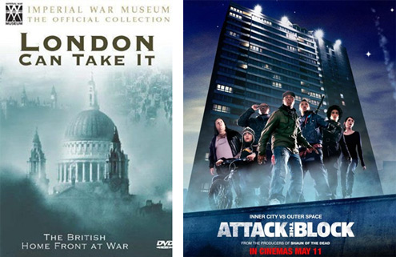click on image to enlarge
Stereotypes are important to study when looking at identity and stereotypes of British national identity include food (Roast Beef, Fish and Chips), drink (beer and pub culture), sport (football and football fans), beliefs, values and attitudes (stiff upper lip, spirit of the blitz), geographical landmarks like Big Ben and of course language and phrases but importantly they are all promoted culturally through media representations. British film has mediated changes in the representation of national identity over the years from propaganda war documentary films like London Can Take It to much more modern, pluralistic representations in films like Attack the Block and Somer’s Town. Attack the Block challenges on one level the stereotype of gang culture so heavily promoted by mainstream media during the London Riots – only YouTube citizen journalism allowed audiences to get closer to the realities of what was happening on the streets while the world watched on, forming their own opinion on notions of collective identities. Here debates on national identity and the reflection of power in society were particularly important for young people and ethnic groups who felt the ‘hand’ of the state was a catalyst in the disturbances.
Whether representations are mainstream or alternative depends of course on the target audience and where the representations are being exported to – The King’s Speech for example encodes, and is deferential to traditional representations of British national identity but was also successfully distributed to American audiences who stereotypically enjoy representations of British cultural heritage. High production value period dramas likeDownton Abbey, Jane Eyre and Sherlock maintain this stereotype. In 2006, The Queen, directed by Stephen Frears explored both traditional representations of British national identity but also suggested evolving, more contemporary, shifting beliefs. Tony Blair was represented as a moderniser who wanted to reform the royal family with the suggestion that The Queen in particular had to modify her own traditional, hard line on protocol (very stereotypically British) because of her declining popularity.
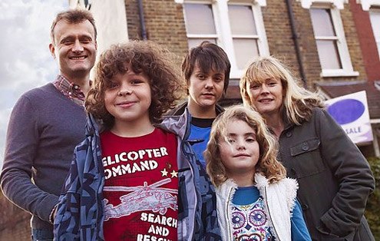
Earlier we looked at a screenshot from This is England which also analyses the concept of what it is to be British but in the 1980s at a time of high unemployment and during the decline of the manufacturing industry. Whatever film or media text, social class often underpins the representation of British national identity with some media artefacts like situation comedies defining ‘Britishness’ through these divisions – sitcoms likeOutnumbered represent urban, middle class, aspirational British national identity whileGavin and Stacey focuses on working class British culture but not in the extreme way thatOnly Fools and Horses offered hyper real characters and narratives. The Alfred Hitchcock film, The 39 Steps in 1935 represented hegemonic divisions of British social classduring the music hall scene when the working class (who are drinking beer and shouting) end up fighting but not before asking Mr Memory questions about sport and horse racing.
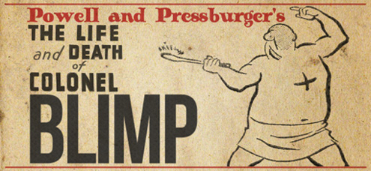
The Life and Death of Colonel Blimp in 1943 and The Ladykillers in 1958 also represented British stereotypes including eccentricity, tea drinking, poor weather, accents and again social class but like The 39 Steps reflected a more historical tradition. Controversially however for 1943, Winston Churchill tried to prevent The Life and Death of Colonel Blimp from being distributed because of a negative perception of Britain’s involvement in WWII. In the same way, British support for armed struggles around the world is represented in different ways by different media – traditionally, the newspaper industry has been the barometer of media political ideology with The Guardian representing liberal, left wing values who would have rather seen a withdrawal from countries like Afghanistan, long before British troops started leaving the country while The Sun and The Daily Mailhave often supported British involvement, often alongside the US in direct action abroad.
Audiences who support this more traditional, hegemonic British national identity also often buy into nostalgic representations of Britishness found in the classic establishing shots of stately homes in period dramas and hedonistic, pleasure seeking representations of the British upper class in television drama. Mainstream media is for mainstream audiences and importantly, audiences actively enjoy representations of British national identity that are not controversial and do not challenge the status quo. More pluralistic films like Four Lions do challenge these stereotypes and represent Britain as multicultural (albeit through difficult humour and controversial narratives). This film was accused however of reinforcing other, regional and religious stereotypes. Regional identity is crucial in understanding Britishness and Four Lions also represents northern, Pakistani British culture while films like Submarine explore Welsh national identity. An opposing argument suggests that ‘we’ are more British than we think and belong to a collective identity circulated by the media. Newspapers will use words like ‘we’ and ‘our’ to suggest this shared identity, e.g. The Sun frequently describes British soldiers as ‘our boys’ in its direct,inclusive mode of address.
British national identity is then, subject to audience uses and responses (the Uses and Gratifications model could be employed here as a framework) but also the production as much as the consumption of media. British national identity used to be more fixed but diversification has ensured, as Anthony Giddens would argue a more fluid representation that is continually updated, revised and change. It is also in the interest of certain groups to represent British national identity in certain ways – whether for commercial or ideological reasons. Gauntlett again suggests that even though the media “offers possibilities and celebrates diversity” it also “offers narrow interpretations”. Diverse and more pluralistic interpretations of British national identity will always have to battle against the power of mainstream media in reaching audiences. Hegemonic collective identity has the ability to ensure dominant culture is maintained while at the same time assumptions are reinforced and circulated as common sense.
The Huffington Post is an online news blog that utilises digital technology to challenge mainstream news media – it openly and commonly criticises David Cameron and his administration and frequently runs stories on the “Cost for Britain of Iraq and Afghanistan” revealed while mainstream media like UK Border Force and Immigrant Nation continually explore the moral panic that British culture and identity is being eroded by immigration. The Sun (see below) ran a front cover supporting this ideological viewpoint by again appropriating the St. George Cross by drawing a red line down the side of the page as ametaphor for ending immigration while using upper case white text anchoring the graphic. An imperative command was given to the reader: “As PM flies to meet EU leaders, You Tell Him” with connotations of a shared ideological standpoint. The concept of ‘the other’ is very common in news narratives and used Levi-Strauss’ binary oppositions to drive a divide between the idea of ‘us and them’. Print media and TV News are ideal conduits for encoding this form of political ideology, often combined with emotive language to reinforce meaning.
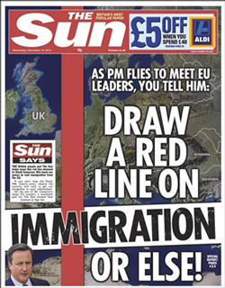
Zygmunt Bauman reflects this conflict in his suggestion that identity, as a reflection of society is problematic. With a declining turnout at General Elections, 65% in 2010 and interestingly (dependent on area) approximately 20-25% turnout at local elections who is to say that government policy and socio-cultural legislation has any legitimacy in relation to British national identity. The role of the individual and the individual in society as resisting categorisation is wholly relevant – often, national identity only becomes an issue when something is assumed to be fixed and stable but as Kobena Mercer would argue then becomes “displaced by the experience of doubt and uncertainty”. This is what UKIP have been exploiting in the last two years and have been using the argument that British identity and British culture is being eroded. They frequently referenced Heritage Culture which limits itself to nostalgic representations (like period drama) is more English than British, launders and sanitises any misdemeanours from past and targets C1, C2 and D white audiences.
Regional identity is part of British identity and is often ignored because of the national identity umbrella term. Game of Thrones and Doc Martin are interesting texts to study that reflect regional identity within the framework of national identity. An ideologically preferred southern identity is apparent in Game of Thrones where in the south there is more money, people are better dressed, even the building has cleaner lines and talk using a moreelaborated language code. In the north, the terrain is rugged, hair and beards are worn long, heavy drinking is more apparent as is shouting and fighting. Clear binary oppositions are used to encode a division between the rich and the poor, the haves and the have nots, the south and the north. In a similar way, Doc Martin is a well spoken London Doctor who drives a Lexus, wears sharp suits and has a significant level of education while the villagers in the fictional Cornish village of Portwenn are scruffily dressed, a little backward in terms of social and political awareness and clearly see Doc Martin as an aspirational GP who can provide for their needs. The UK is a population of nearly 65 million but the bulk of business and commerce is concentrated in the south-east of England leaving regional identity subject to cultural stereotyping and up to a point, marginalisation.
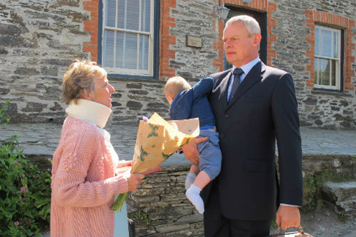
British national identity seems to be immersed in tradition - early settlers to Britain included Celts, Romans, Anglo-Saxons, Normans and Vikings. King Arthur allegedly led the defence of Romano-Celtic Britain against Saxon invaders in the 6th century but so much ancient history is steeped in literary imagination and interpretation – nostalgic media representations of Britishness rely also on this interpretation, e.g. the television drama The Tudors and romantic representation of Henry VIII. Tales of legendary, mythical English Kings are depicted in Geoffrey of Monmouth’s 12th century ‘Historia Regum Britanniae’ if you are that interested in pursuing what has been credited as being a wildly inaccurate, jingoistic accounts of British history. 1066 did happen however and changed everything - along came the French in the guise of William the Conquerer, the Normans, Feudalism and hundreds of years of war. The Normans established much of England and English tradition that we know today and lexically and rhythmically moved the English language away from the harsh Germanic intonations spoken by Anglo Saxons. Comedian Al Murray’s character, the Pub Landlord will simply have to accept that the British are historically a blend of French and German culture. In his book, ‘Think Yourself British’ he suggests that the French have ‘no rules’ while the Germans have ‘too many’ but he also satirises The Sun’s frequent headlines on ‘Broken Britain’.
Broadcast news and print media are currently devoting a significant amount of time and column space to the forthcoming vote on Scottish independence and in terms of the probability of the outcome, ideologically the dominant culture will undoubtedly endure leaving audiences again with a stark reminder on where the money power base is in the UK. As The Daily Mail online said today, encoding mythical shared news values and with words ‘we’, ‘our’ and ‘us’ prominently featuring: “What is at stake, on both sides of the border, is our British identity – the bond that has joined us in war and peace since Queen Anne fulfilled the Union dream of her Stuart ancestor, King James. Ever since, in science and commerce, industry, literature and the arts, we have shared each other’s triumphs. And in times of peril, from Napoleon and Hitler to the collapse of Scotland’s banks in 2008, we have stood side by side”.

