Representations of Disability
Rob Miller | Tuesday August 09, 2011
Categories: Key Concepts, Representation & Stereotyping, Hot Entries
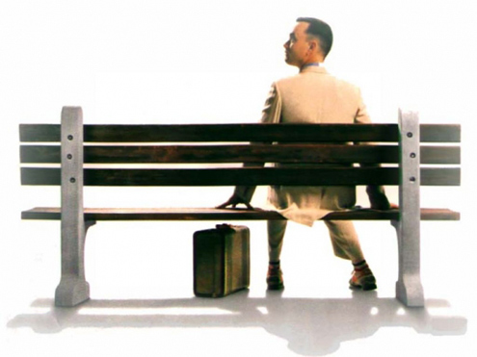
Change continually affects the way we teach representation. Technological advancement would be the most obvious change, try telling your students they are in the middle of the fastest paced technological revolution the world has ever seen and they will look at you with a blank face because they are living it – this continually evolving form of change for many has been ‘normalised’. Web 1.0 to 2.0 and now Web 3.0 are generic terms banded around that are often misunderstood; in a similar way that Martin Bell described television coverage of war and conflict in 1993 as “immediacy without understanding”, digital distribution, user generated content and so called ‘new media’ representations need to be re-evaluated in terms of Media Studies.
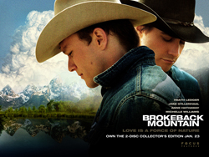
Socio-political change is potentially less obvious in it effect on the way we teach the subject.
Brokeback Mountain for example would not have received such widedistribution had same sex Civil Partnerships not become more common and legalised in some US states and in the UK in 2005.
A Black American US President and the first female head of the IMF have been catalysts for pluralistic change in terms of representation of race, ethnicity and gender while desensitisation and deregulation has paved the way for more graphic, challenging texts like the Saw franchise
Politically sensitive developments thanks in part to Wikileaks and July 2011 upheaval s at the News of the World and subsequently their parent company, multi-national conglomerate News Corporation and the institution of the Metropolitan Police undoubtedly will have effects on the way we approach teaching certain topics but what about Representation of Disability?
One argument suggests despite positive representations of disability in society e.g. Paralympic success, representation of disability in the media is more about tokenism andvoyeurism than pluralistic change. Counter to this argument it could be suggested thatmainstream media continually seeks to reinforce hegemonic cultural stereotypes in all areas of representation for the purpose of entertainment values – this compelling argument needs no evidence but disability still remains curiously and clumsily represented in the media. My aim is to discuss and explore key texts that can be used as case studies in the classroom to develop debate within this area of study.
Fox TV’s Glee foregrounds a disabled character in Artie:
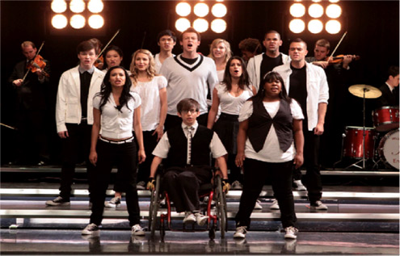
Artie Abrams is played by able bodied actor and trained dancer, Kevin McHale. In the above publicity photograph he is framed centrally, with his disability is foregrounded – as one of the central protagonists he conforms to many of the show’s narratives which revolve around cast members struggling to deal with notions of difference like sexuality and social issues through performance. This performance is used as a form of escapism from issues in their personal lives and the show on a manifest level champions the causes of minority groups. Artie’s back story is that he is a guitarist and paraplegic manual wheelchair user who has a spinal cord injury sustained in a car crash when he was eight years old.
In Season One Artie beings to accept his disability and takes an active part is each performance, manually manipulating his wheelchair as part of choreographed dance sequences. He finds himself a girlfriend as part of his involvement in the school andaudiences are positioned to understand that in one episode he loses his virginity. One entire episode, ‘Wheels’ is devoted to his disability where the Glee team spend two weeks in wheelchairs attempting to empathise with Artie and also raise money for a ramp and a bus with a disabled floor – to facilitate this they sell Cup Cakes in the school that are an unexpected success after Marijuana is included as an active ingredient. This creates significant humour and entertainment values and well as adding to the feel good factor the show encodes for its youthful, teenage aspirational target audience. Artie is inevitably subject to cultural stereotyping but ultimately the cast are seen to begin to understand the day to day issues he faces. Audience identification is anchored through emotiverepresentations creating sympathy for his plight but as with every mainstream text are left with a smile on their face in terms of narrative outcomes – the cast successfully raise money for the bus while Artie ensures a ramp is built in the school with the closing scene being the whole cast, in wheelchairs performing a song and dance routine to ‘Rolling on the River’.
During the Glee stage tour Artie is seen performing an able bodied dance routine by live audiences. The stage lights dip and Artie is isolated, centre stage top lit in a circular spotlight. The audience’s anticipation is palpable as he slowly, but with measured determination removes himself from his wheelchair and stands – at this point the audience are now screaming as colleagues emerge from stage left and right, throwing a blue glitter jacket over his shoulders and a hat. The stage lights go up and Artie as the principal dancer performs ‘Safety Dance’ by Men Without Hats flanked by twelve other performers, running up and down the stage and extended walkway into the crowd to ecstatic applause and appreciation by an almost frenzied crowd. After two and a half minutes equilibrium is restored as the dancers retreat, the stage lights go down and Artie is returned to his wheelchair and spotlight. The event is represented as a ‘miracle’.
Using Stuart Hall, dominant and oppositional readings can be drawn from Artie’s representation – the show received criticism for a dream sequence in one episode where Artie is also seen to perform as an able bodied dancer with the suggestion that the casting of Kevin McHale as an able bodied dancer to perform this role was inappropriate.Preferred or dominant readings encode a positive representation of disability for amainstream target audience, the show is inclusive in its representation of minority groups and Artie is seen by audiences to live a normal life, albeit as a struggle, alongside other able bodied cast members. He even gets one episode devoted to his character which is thegeneric format of this Musical Drama.
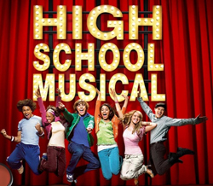
The show has been written about from a sociological perspective challenging the manifest, escapist, surface representations of programmes from the same genre like High School Musicalciting the cultural melting pot that is thedemographic of the cast (see above poster) – two Jewish performers, one black woman, one gay man, a Chinese couple, one mixed race performer, one female Latina, three white Americans and an occasional Filipino singer.
To further anchor these representations some of the cast are overweight. It ticks all the boxes in terms of multicultural representations, body shape and size, sexuality and disability including a Cheerleader with Down’s syndrome.
From the perspective of negotiated or oppositional readings Artie’s representation isvoyeuristic and used as a vehicle for emotive entertainment values and to only tick boxes, not to encode positive or pluralistic representations. The work tokenism has been levelled at the show in the same way that many college or school prospectuses will clumsily but often accurately reflect the demographic of the area with a range of ethnic mix and the occasional student in a wheelchair on the front cover. Notions of institution have to also be referenced with the show produced and distributed by Fox Television, a network not known for its stable of challenging texts exploring complex narrative themes.
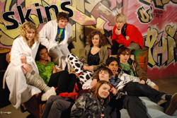
Cynically like 24, arguably Glee’sprimary intention is to exploit cultural stereotyping for the purpose of ratingsand advertising revenue ensuring commercial success before critical success.
The primary target audience again is crucial for these shared or evenaberrant readings – female skew, multicultural, 12-19, urban or city living,mainstreamers and aspirers with texts like High School Musical, Skins, Hollyoaks and Scrubs as existing cultural reference points with a significant homosexual male secondary target audience. The DVD of Glee is BBFC classified as 12 which again has been a focal point for discussion with some younger audiences stating the representations ‘made me uncomfortable’ while other stated it wasaspirational and ‘gave me hope’.
Objective representation in fiction based moving image media has entertainment values, commercial success and often advertising revenue as primary objectives before notions of realism. New digital media is often about immediacy to the point that sometimes the need to be entertained negates the process of the construction of meaning through representation while non tabloid print media and talk radio have time to explore key issues with their ever decreasing niche target audiences.
Media texts are selected and constructed and mediated to a target audience to ensureaudience identification and cultural stereotyping – in 1994 Forrest Gump was introduced to global audiences who watched the American Dream unfold as a ‘simpleton’ from Alabama with childhood leg braces gained a football scholarship, met John F Kennedy, became a decorated Vietnam war hero awarded the Medal of Honour, subsequently while recuperating became a Table Tennis champion, was employed by Richard Nixon as a Diplomat only to find he ‘inadvertently’ exposed the Watergate Scandal , started his own successful fishing company, discovered he has a son and married his childhood sweetheart.
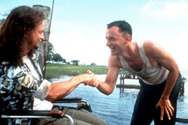
On a manifest level Forrest Gumpstates clearly to audiences through strong, emotive, feel good representations that an individual can achieve success in life against all the odds – even his friend Lt. Dan whose life he saves and who has lost both of his legs in Vietnam eventually thanks Forrest for saving his life when previously he had told him he wished he had left him for dead.
Audiences smile a lot and cry a lot while watching the film and to many the film is inspirational but without the hyper real representations it would have had limited success and limited distribution. Arguably objective representation of disability is left to the non-fiction genre of Documentary but here often subjectivity is more apparent than it is in fiction based media – Expository Documentary often encodes preferred meaningsthrough ‘voice of God’ narrative voice over, Interactive Documentary involves more audience participation and perspective, Reflexive Documentary can challenge notions ofdocumentary realism but only Observational Documentary borrowing from traditions ofCinema Verite offers anything close to objectivity.
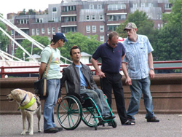
Editing however in any media form is crucial to the production of meaning – there have been many positive documentaries about disability but often the marketing of these programmes is questionable seen through avoyeuristic lens and through difficult programme titles such as C4’s The Crippendales, Blind Young Things andCrip on a Trip.
When viewed the narrative content of all these three documentaries contain motivating and inspirational scenes but within a voyeuristic framework. Some documentaries however seem to have broken new ground recently with a raft of programmes that make no attempt to even try and conceal their voyeuristic obsessions in regards to representing disability; Embarrassing Bodies has become a catalyst for programmes like C5’s Extraordinary People or C4’s Half Ton Son and Body Shock where audiences are deliberately shocked by images that, using Levi Strauss are in binary opposition to perceived values of normality.
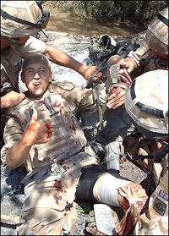
Tabloid representations of disability take a similar approach to voyeuristic documentaryand use the same conventions – emotive imagery with a high ratio of image to text. The more traditional, so called right wing press tend to carry a significant amount of stories about injured British soldiers who are now fighting for compensation and have a more campaigning approach to the subject of disability.
In July 2011 The Sun ran a story about a soldier who had lost both of his legs and sustained permanent groin injury after stepping on a landmine, he is campaigning for soldiers to be subsidised if they wish to donate sperm before being deployed to high risk conflict zones taking the high cost of this process into consideration. These stories are more often than not inspirational and emotive in their mode of address and although contained within tabloid publications like The Daily Star or The Daily Mirror, mid market tabloids like the Daily Mail or weekly magazines like Now, Women, Closer, Reveal and Take a Break are arguably are less voyeuristic than moving image media even though they are seeking to maintain and improve on circulation figures and ensure continued advertising revenue.
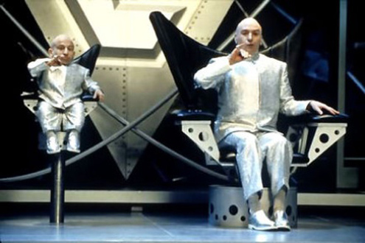
Representations of Dwarfism are rooted in voyeurism, then and now from the 1937 film,Snow White and the Seven Dwarfs through to Mini Me in Austin Powers. Actor Verne Troyer who played Mini Me entered into the ultimate cultural stereotyping fish bowl in 2009, Celebrity Big Brother. Interestingly, perhaps because his ‘difference’ was so significant, bookmakers voted him most likely to win and, as a result was the favourite from the start even though he came fourth. Big Brother and Endemol are no strangers to controversial representations; Big Brother Nine’s contestants included a deported Albino songwriter and a blind radio producer. The whole concept of Big Brother depends on notions of cultural stereotyping to encode entertainment values and audiences need to identify with these characters and contestants to maintain interest and importantly ensureinteractivity. The closer the show came to being pulled and ultimately sold on to C5 the more extreme and hyper real the representations became ensuring the last drop of revenue was ‘rinsed’ from the show.
Famous Dwarf actors have graced the small and big screen from David Rappaport to Verne Troyer. Films like James Bond’s Man with the Golden Gun and Time Bandits have created characters that have been played by Dwarfs while the Fantasy genre clearly lends itself to roles being played by Dwarf actors. Acting Agencies like Oh so Small Productionsrepresent emerging Dwarf actors but crucially and importantly it is the audience perception of these representations and subsequent potentially passive effects that are crucial to understanding how meaning is encoded and decoded. ITV2’s Tabloid News Quiz ShowCelebrity Juice, presented by Keith Lemon with team captains Holly Willoughby and Fearne Cotton in July 2011 had a JLS band member standing behind a green screen body cut out of Verne Troyer with his own head inserted through a hole above the body – the game was who am I, the audience laughed hysterically when they had access to the answer to this question before the panel did. Although, an ex colleague of mine with Dwarfism is more than happy to remind me that he would have been monumentally happy to exchange his then salary with a financially lucrative film contract instead but the debate surely must be, is it exploitation, is it preventing normalisation and at the same time maintaining symbolic annihilation, is it crudely using a medical condition to sell cinema tickets? This is, and always will be an expansive debate.
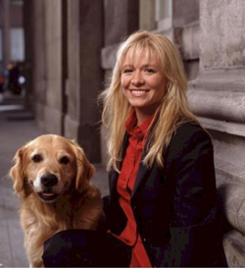
Characters in the media with some form of disability ensure audiences are engaged and interested, identify and often sympathise with the representation.
A key convention of Crime Dramacharacters can be an eccentric, troubled or unusual central protagonist. In ITV1’sLewis, following on from the psychologically problematical character of Morse his wife (Lewis’) is killed off to facilitate the change from Morse toLewis, the same occurs to Detective Mac Taylor in CSI New York but disability more often than not is used as a key focus in terms of audience identification.
Sue Thomas FB Eye presents audiences with a profoundly deaf investigator who has a high end ability to lip read, Monk in the programme of the same name has OCD and it is the condition that helps him to solve the crime while in the Medical Drama House the Hugh Lawrie character walks with a cane after a serious motorbike accident.
Fiction television programmes sometimes with difficulty dip in and dip out of representations of disability if relevant to the storyline - recently an episode of My Name is Earl represented Earl playing basketball while in a wheelchair, in a coma with a team of other wheelchair users with the narrative premise being that Earl was seeking forgiveness from when he stole his friends wheelchair when they were both children. Ricky Gervais on the other hand is happy to leave his wheelchair bound colleague at the top of a set of stairs in The Officeduring a fire alarm drill to make a point about how some people are uncomfortable with the way they perceive disability. Disability is now more foregrounded in the media than ever but critically it is how this representation is mediated. BBC News employ journalist Frank Gardner who is confined to a wheelchair or sometimes a frame after being shot in Saudi Arabia in 2004 – despite his injury he still, wherever possible reports from the field including war torn countries like Afghanistan and is an inspiration to many along with the many disabled runners who are regularly reported on every year running the London Marathon. It is always worth going though going back to basics sometimes and remembering that representation is exactly that, a re-presentation that is decoded usingpreferred, negotiated or oppositional readings by audiences.

