The Double (2013)

Production and Production Values Plus Issues of Regulation
The Double is Director Richard Ayoade’s second feature film. The first, Submarine (2011) received critical success and was produced by Warp, funded by Film4 and the old UK Film Council’s New Cinema Fund with a limited release (60 UK screens) by Optimum. The Double went for a very similar classic funding model for independent British Film with again funding from Film4 (they retain the British TV rights) and the BFI (having taken over the role of distributing national lottery funding for film from the disbanded UK Film Council). The actual production company was Alcove Entertainment. The Double was distributed by StudioCanal UK who were previously known as Optimum Releasing. Richard Ayoade as well as being known for previously directing Submarine is an English comedian, writer and actor known for his roles in The IT Crowd, Gareth Marenghi’s Darkplace and The Mighty Boosh. The sometimes postmodern, surreal representations in these texts has heavily influenced the complex narrative of The Double, based on an 1846 novel by Fyodor Dostoyevsky of the same name.
As with Submarine Executive Producer Ben Stiller who helped to sell the film in the US, Ayoade brings in Michael Caine as co-Producer, with cameo performances from his iconic British actor father-in-law James Fox, old mate Chris O’Dowd from the IT Crowd and Chris Morris to anchor the subversive narrative. Ayoade proves he is ‘well connected’ in the industry after only two features and is developing his own unique style, particularly visual style in terms of filters (mainly red), unusual framing, oblique camera angles, cutting that resists narrative continuity, framing of subjects in empty narrative spaces and unique use of music. As much as Ayoade can be an auteur after two films, he is moving in this direction.
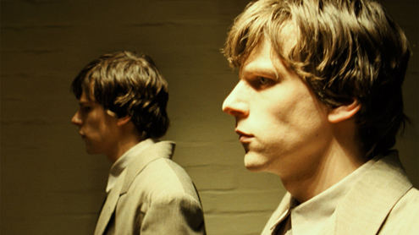click on image to enlarge
As a low budget independent feature it was partly filmed in a closed business estate in west London which had formally been a car testing facility which gave the production team flexibility and the ability to dress the set as they pleased while keeping costs down. As filming progressed they found different areas to film different scenes in which gave it thedystopian, timeless, bleak, claustrophobic subterranean appeal – an underground concrete alley was found under a carpentry shop which became the perfect connecting passage for the main characters on the walk from their office to home.
The BBFC passed The Double uncut with a 15 certificate because of the strong language, representation of suicide and suicide references. The themes of the film were seen to bemetaphorically dark enough to warrant the rating but the context was important in terms of a lack of realism – it was set in a surreal modern day America switching the book’s narrative from the mid 19th century. It was unlikely that passive consumption, via imitable techniques would be an issue with this film, particularly considering its target group.

Marketing and Distribution, Globalisation and Digital Technology
Critical acclaim followed the film at the 2013 Toronto film festival, LFF and the October 2013 Tokyo Film Festival. Release dates were put back to 4th April 2014 perhaps intentionally referencing the BAFTAs (16th February, 2014) and the Academy Awards (March 2nd, 2014). StudioCanal UK gave the film a limited release in the UK while Magnolia released the film in the US with marketing relying heavily on a print and poster campaign targeting an educated, more niche, film literate ABC1 25-45 target audience. This audience would be familiar with the work of Ayoade and have cultural capital and expectations of his unusual style of filmmaking and approaches to comedy and satire. In many ways it was just about getting information out to this audience (many of whom went to the LFF premiere) about when the film was going to be released – an independent ‘event movie’.
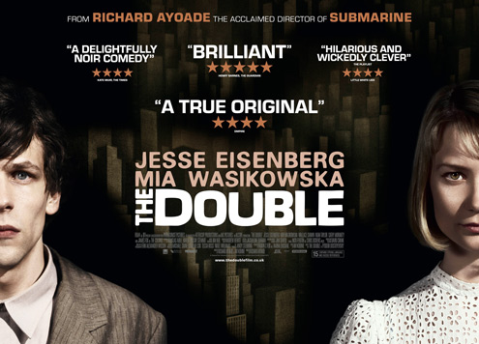click on image to enlarge
Stereotypically the print and poster campaign focused in and around London (tube stations and walkways) and also in densely populated university towns like Sheffield (where Warp films are based who made Submarine) and Manchester. Digital technology enabled viral activity which was significant with trailers seeded on YouTube and social networking feeds such as Facebook, Twitter but also film blogs and film social networking sites such as iCheckMovies and in particular, MUBI that focuses on independent, experimental and international films. Chat focused on where Ayoade was going to go after his first feature, was the film going to more or less accessible than Submarine and the almost total ransacking of the Submarine cast with addition of Jesse Eisenberg. The film was shot on DV and used some CGI in flashback scenes but costs were kept down with a small cast and crew. The idea of whether the film has global appeal is an interesting one with the initial reaction a no because of its status as a low budget British independent film (institutionally).Culturally however, the film has a broad appeal with American actors and American references but a niche subject matter. The narrative itself is what prevents the film from receiving any significant global distribution despite having a limited release in the US. It is already entering the domain of the cult film as a result of it surreal, postmodern narrative.

Audiences - Targeting, Positioning, Response and Appeal Including Star Quality
The Double provided a form of escapism for audiences with the representation of a surreal world that was a challenge to understand. This intellectual challenge was a selling point to the film with the educated, niche, and film literate ABC1 25-45 audience enjoying a difficult take on a complex, historical Russian novella. The film positioned audiences into a form of empathy via audience identification with a protagonist who struggles at work, struggles in his personal life and is eventually usurped by his doppelganger. This is not to say any one of the audience has a doppelganger – in the film Simon is simply a metaphor for struggle. Appeals also included dark narrative enigmas, non-realist, escapist representations, a timeless appeal, cine-literate intertextual representations, Ayoade’s impressionistic visual style and star marketing.
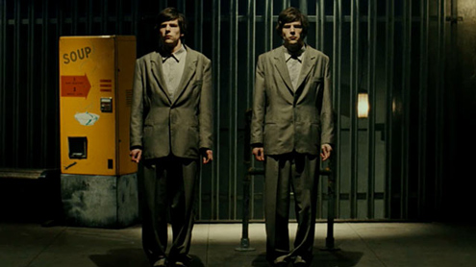click on image to enlarge
Star marketing of course includes the Director Richard Ayoade but also the main protagonist, Jess Eisenberg: Social Network- Mark Zuckerberg, 2010 who plays Simon who is slowly assumed by the more confident, strident James. They both fall for colleague Hannah played by Australian actress Mia Wasikowska: Amelia, 2009 – Elinor Smith, Alice in Wonderland, 2010 – Alice, Jane Eyre, 2011 – Jane Eyre and Only Lovers Left Alive, 2013 playing Ava. In this regard you could argue, along with James Fox and co-producer Michael Caine the oxymoron of an independent film that utilises star marketing applies.

Narrative, Genre and Representation
The Double suggests many intertextual references, not least to 12 Monkeys, Fahrenheit 451 and Rear Window in a not so obvious post-apocalyptic way. It has science fiction connotations with the mise-en-scene including subterranean offices, long low-rise housing estates, a lack of reference to any semblance of normality in the outside world andvoyeurism. The Double it must be stressed is not set in a post-apocalyptic world, more a world that cannot be fully identified by the audience, especially in terms of time. Occasionally objects (an Ambulance at the end) suggest the 1970s but this is deliberate – the underground, dingy cavern like spaces and tunnels where Simon works as a Clerk writing reports for a ‘human resources’ organisation that James Fox controls are claustrophobic and unnerving.
Old men predominate in what appears to be some form of government department Simon works for – they have a primary role in anchoring the surrealism. In many scenes, corridors and doorways the old men are seen blankly staring at Simon who fails in mostly everything he does from working the lift, ordering food in a café to attempting to court Hannah. His life, and the film’s diegesis are wholly dysfunctional, ending in attempted suicide in the hope that he will rid himself of his doppelganger. Use of narrative enigma predominates throughout with the audience constantly asking themselves questions, some of which are never resolved. This narrative fragmentation, using Lyotard’s framework suggests that the film has a number of micro narratives that work to almost replace a more obvious, mainstream macro narrative. An oppositional reading could be that there is some form of encoded meaning but using Derrida’s post structural framework, it is not the author but the audience who are producing meaning.
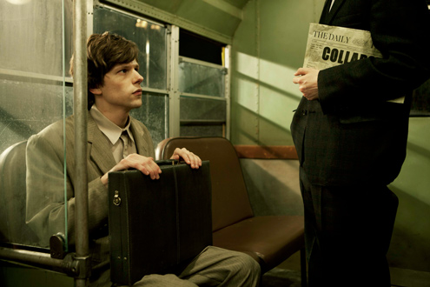click on image to enlarge
On this level, there a form of narrative structure in that we are introduced to Simon and his surroundings and we do see disruption in the arrival of James and a resolution in the final suicide scene but meaning arguably is open ended and at time bleak allowing for audience reflection. Narrative themes include isolation, loneliness, fear of the future and power and control. While Simon is a pluralistic representation of gender, Simon is a hegemonic construct in that he is powerful and in control of his destiny. Although both characters are played by the same actor, body language, facial expressions and movement make Simon appear as physically weak, totally lacking in confidence and able to be manipulated. James moves through narrative space in a confident, strident way, he is an excellent verbal communicator and makes direct eye contact with those he is in conversation with.
In many ways Hannah is the same female equivalent to Simon in that she is also vulnerable, lacking in confidence and does not conform, like Simon to any form ofcollective identity. They are both disparate individuals, working for a powerful corporation headed by the dominant patriarch ‘The Colonel’ – Ayoade places ironic images of The Colonel in and around Simon and James’ workplace in a self referential homage to his father-in-law James Fox who plays that role. Further gender based irony is represented through the brief role of Jack as PT Kommander played by Paddy Considine who whips The Colonel’s workforce into shape through series of physical workouts and routines seen through the medium of television. This makes clear intertextual references to Considine’sironic macho character in Submarine, Graham T. Purvis who is a leather-clad psychic who uses ‘light’ in his dynamic self help groups. Ayoade makes a strong point about gender in society and through these characters meaning is encoded.
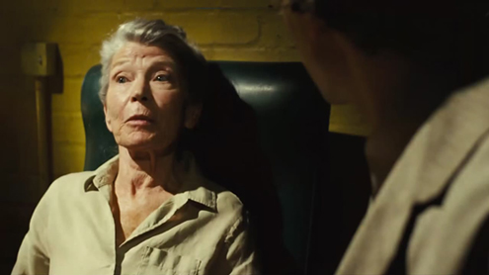
Age is represented in a pivotal way, not just through the nagging Mr. Papadopoulos but also through the raft of old men that populate the corridors and doorways of the underground maze. Perhaps Ayoade is making a point about longevity, about notions of existence but their role is interesting in how they make the film seem darker, more foreboding and mocking almost predicting that Simon/James will not reach their years. Simon even hears of his old Mother’s death in a corrupt nursing home through his answerphone message while the suicide department has a young Detective played by Craig Roberts who plays central character Oliver in Submarine – age seems important in the film. The word dysfunctional applies to most of the characters within the narrative withdominant and oppositional readings applied even to narrative closure and the last few frames of the film – we think that Simon has successfully killed James who bleeds to death in his apartment after Simon’s attempted suicide. He is seen in the ambulance with The Colonel and Hannah saying “I like to think I’m pretty unique” emphasising again the role of the individual in society but how did The Colonel get there in the first place as he was nowhere near when Simon jumped?

