Understanding Audience
Jeremy Orlebar | Tuesday December 01, 2009
Categories: Key Concepts, Audience, Understanding Media, Understanding Key Concepts
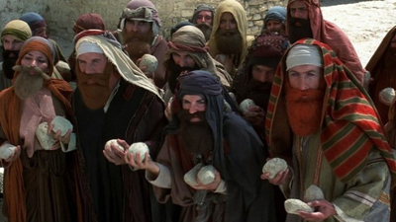
Everyone has been in an audience. We have all been part of a group of people who come together to experience music, film, theatre or other live event. In media terms the audience is any group of people who receive a media text, and not just people who are together in the same place.
They receive the text via a media carrier such as a newspaper or magazine, television, DVD, radio or the internet. It can also be a mobile phone, iPod or any other device that stores or receives media messages.
‘Audience’ is a key concept throughout media studies, because all media texts are produced with an audience in mind - that is to say a group of people who will receive the text and make some sort of sense out of it.
So audience is part of the media equation – a product is produced and an audience receives it. Television producers need an audience for their programmes, so they can finance those programmes and make more programmes that the audience likes. Advertisers need an audience who will see or hear their advertisements and then buy the products.
A media text is planned with a particular audience in mind. A television producer has to explain to the broadcasting institution (e.g. BBC or ITV) who is the likely audience for this particular programme.
Are they under 25 years old or older, mainly male or mainly female, what are they interested in? The television audience varies throughout the day and night, and television and radio broadcast for 24 hours, seven days a week. How do we know who is watching or listening at any one time? This is where audience research becomes important. A media producer has to know who is the potential audience, and as much about them as possible.

Activity
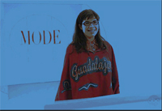
Discuss the make up of the audience for the very successful US situation comedy Ugly Betty.
What does it mean for a TV show to be successful?
Audience research is a major element for any media producer. Companies are set up to carry out audience research for media producers, broadcasters and advertisers.
These research companies use questionnaires, focus groups, one to one interviewing, and electronic devices to find out about people’s life styles, and television viewing habits as well as the type of products they want to buy.
Short extracts or trailers for up and coming programmes are often shown to focus groups to see how they react. If they don’t like something then the producers may make some changes. Hollywood films are regularly ‘trialled’ in front of cinema audiences in America. In some cases the ending of the film is changed because the trial audience do not like it. Sometimes several endings are filmed and the trial audience asked to choose the one they like best.
Media producers spend a lot of time and money finding out who the audience for a programme or media product might be. It’s a serious business; media producers want to know how the audience is made up. A mass audience is very large, so ways of breaking it down into categories have been devised.

Activity
A new fragrance for teenagers is on the market called COOL.
The company has asked an advertising agency to create a 15secs television commercial, and full page, glossy, colour print advertisements for magazines. The audience for this new perfume is young teenage women.
The advertiser must make sure this audience is watching when the advertisements are broadcast. It must target the right audience for the perfume to succeed. If the advertisement was broadcast during an episode of Friends or during a romantic comedy film would this be the target audience.
Where would the print advertisements be placed for maximum target audience exposure – it might appear in Sugar or Bliss but is this the right place to advertise scent?

Audience Research 1: Demographics
A common and traditional method of audience research is known as demographics. This defines the adult population largely by the work that they do. It breaks the population down into 6 groups, and labels them by using a letter code to describe the income and status of the members of each group.
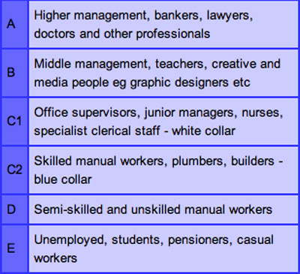
These audience demographics are based on the National Readership Survey’s socio-economic grades see http://www.nrs.co.uk
Producers need to know the demographics of their potential audience so that they can shape their text or product to appeal to a group with known viewing habits. Producers of a television programme about DIY would have a target audience with a C2 demographic – what other demographic group might that programme expect to be in the audience.
This is not of course a complete picture. It does not tell the media producers some things they would like to know, such as how much money each group has to spend each week.
Some skilled manual workers, like electricians, earn more money each week than say a teacher, but they probably do not spend it in the same way. Also demographics is only about the main earner in a household so young people at home – for example, are not included.

Audience Research 2: Pyschographics
This is a way of describing an audience by looking at the behaviour and personality traits of its members. Psychographics labels a particular type of person and makes an assessment about their viewing and spending habits.
The advertising agency Young and Rubican invented a successful psychographic profile known as their 4C’s Marketing Model http://www.4cs.yr.com The 4 Cs stand for Cross Cultural Consumer Characterisation. They put the audience into groups with labels that suggest their position in society
Try and work out which category you fit into and one which you would like to fit into.
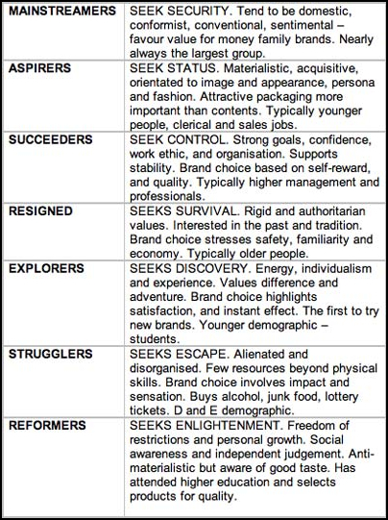
This 4C’s Marketing Model needs a bit of getting used to. It is very useful for marketing a product as it can point to the most likely target audience for that particular product. This marketing model will be useful when you come to decide on the target audience for your practical project.

Activity
Try working with this theory by creating a psychographic profile of the audience for each of the following:
- Buying digital camera
- Watching a horror movie
- Going on a package holiday.
When you are studying audiences you will find that there are a lot of different theories about why some television programmes have a large audience and others do not, and why people buy certain things and not others.
There are also theories about the effect that ‘media’ has on audiences.
Here is one interesting theory that tries to explain why we consume different types of media.

Hierarchy of Needs
An American psychologist, Abraham Maslow, suggested that we all have different layers of needs. We have to achieve certain needs before going on to the next layer. Basically we all need to be able to eat and sleep in safety before we can go on to more complex social needs, such as getting married.
His Hierarchy of Needs suggests that once people have their basic needs met like housing, food, safety, shopping, technology, and a job they can then go on to satisfy successively ‘higher needs’ that occupy a set hierarchy or system of ranking.
Maslow studied well respected people such as Albert Einstein, and American presidents, and he studied one percent of the healthiest college student population.
He came up with this pyramid where basic needs are at the bottom and at the top something called ‘self actualisation’. This describes a person who has gained the respect of a lot of other people – perhaps a prime minister – and has a high level of self esteem and self respect.
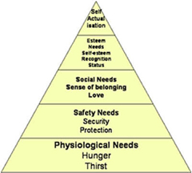
Maslow’s Hierarchy of Needs Abraham Maslow
Motivation and Personality, 2nd ed., Harper & Row, 1970

So what has this to do with media texts?
It is very relevant to advertisers, and institutions that carry advertising – newspapers, cinema, television and radio channels.
Maslow’s upper levels at the top of the pyramid are about self esteem and gaining the respect of others. This can be linked to the idea that consuming particular media texts fulfils self-esteem, as does buying certain products.
In a nutshell Maslow is suggesting that if you buy a new pair of trainers of the right brand as shown to you on in the media, then you will feel better about your self, because you have the respect of other people.
Can you prove or disprove this theory from your experience?

Activity
Draw a pyramid with five levels. Leave the spaces blank.
Fill in each level with examples of media texts which attempt to fulfil that particular level of needs in Maslow’s pyramid.
E.G. take the second from bottom layer – safety needs. An advertisement for car insurance or life insurance offers a general level of safety needs.
Some cars are sold on their safety features – what does this tell us about the audience (people) who buy a car for these reasons?
Now construct an audience for a particular product using the hierarchy of needs, and the psychographic system.
It is important to be able to ‘read’ or understand a target audience, and to understand if a media product has succeeded or not in getting across to its target audience.

Audience Research 3
There are several types of research into audiences and what they watch and want. This is where a specialist company investigates audiences to give information about them back to the media producers.
There are some definitions you need to know.
Primary research for audience research is direct investigation of the needs, desires and media habits of an audience. It involves contacting and talking directly to members of the target audience individually, on the phone, by email or questionnaire or in groups.
Secondary research looks at data and other research that has already been undertaken about the audience – today secondary research is very largely carried out on the internet, and by consulting books, magazines and journals. By consulting a wide range of opinions and sources a sound critical analysis can be constructed.
Quantitative research is about collecting facts and figures and other data to do with the size of the audience. This can be a breakdown of the number of people, including their gender, age and location, who make up an audience. TV audiences are measured in a quantitative way by BARB – Broadcasters’ Audience Research Boardhttp://www.barb.org.uk .
Radio audiences are measured by RAJAR Radio Joint Audience Researchhttp://www.rajar.org.uk .
Qualitative research is about investigating the reasons why audiences consume a particular text. Qualitative research is done through discussion and by setting up focus groups. Questionnaires can be constructed to establish audience preferences, opinions, tastes and desires, or to measure the success of a media text or product.
Research alert: small scale questionnaires about a media product from a limited audience (such as a school) carry little weight or value.

Activity
Look at these audience viewing figures for the five terrestrial channels from BARB for August 2007:
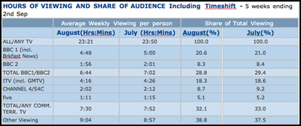
© BARB Ltd 2007
- What can these figures tell us about the way each of us consumes television during the summer?
- What does it tell us about the split between the Public Service Broadcaster, the BBC, and the commercial channels?
- Which is the most useful statistic from a broadcaster’s point of view?
- Which is the most useful statistic from a consumer’s point of view? Look at the BARB website to see a full breakdown of the satellite channels.
Look in a newspaper or magazine for the most watched programmes or headline viewing figures of the week– why are people interested in this quantitative research? Soaps are always the most watched programmes.

Discuss
What sort of programmes might be able to topple the soaps from the top of the charts?
A2 level media exams sometimes include a set of audience figures. The question asks the student to comment on aspects of the figures, or more generally on what a viewing figures chart can be used for and by whom.
The main thing is not to analyse the figures or make specific points about the figures. Instead discuss the value of audience research to a broadcaster or advertiser and to a media producer.
In your essay discuss the different types of research, the value of it and why it is undertaken and what can be deduced by such audience figures.

For A2 you will need to know and understand some of the theories about Media Audiences.
Many theories try to make sense of the question: What effects do media texts have on audiences?
This question has interested people ever since the invention of the printing press, and it became possible to make hundreds of copies of a document, and a ‘message’ could reach a mass audience.
Researchers investigating the effect of media on audiences have considered the audience in two distinct ways.
The earliest idea was that a mass audience is passive and inactive. The members of the audience are seen as couch potatoes just sitting there consuming media texts – particularly commercial television programmes.
It was thought that this did not require the active use of the brain. The audience accepts and believes all messages in any media text that they receive. This is the passive audience model.

Audience Theory 1: The Hypodermic Model
In this model the media is seen as powerful and able to inject ideas into an audience who are seen as weak and passive.
It was thought that a mass audience could be influenced by the same message. This appeared to be the case in Nazi Germany in the 1930s leading up to the second world war. Powerful German films such as Triumph of the Will seemed to use propaganda methods to ‘inject’ ideas promoting the Nazi cause into the German audience.
That is why this theory is known as the Hypodermic model.
It suggests that a media text can ‘inject’ ideas, values and attitudes into a passive audience who might then act upon them. This theory also suggests that a media text has only one message which the audience must pick up.
In 1957 an American theorist called Vance Packard working in advertising wrote an influential book called The Hidden Persuaders. This book suggested that advertisers were able to manipulate audiences, and persuade them to buy things they may not want to buy. This suggested advertisers had power over audiences. In fact this has since proved to be an unreliable model, as modern audiences are too sophisticated.
Basically this theory stems from a fear of the mass media, and gives the media much more power than it can ever have in a democracy. Also it ignores the obvious fact that not everyone in an audience behaves in the same way. How can an audience be passive – think of all the times you have disagreed with something on television or just not laughed at a new so called comedy, or thought Big Brother was terrible.

Audience Theory 2: Cultivation Theory
This theory also treats the audience as passive. It suggests that repeated exposure to the same message – such as an advertisement – will have an effect on the audience’s attitudes and values. A similar idea is known as densensitisation which suggests that long term exposure to violent media makes the audience less likely to be shocked by violence. Being less shocked by violence the audience may then be more likely to behave violently.
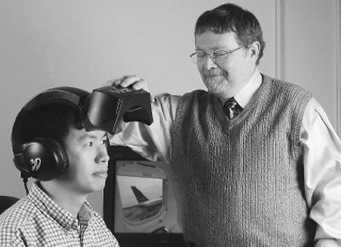
The criticism of this theory is that screen violence is not the same as real violence. Many people have been exposed to screen murder and violence, but there is no evidence at all that this has lead audiences to be less shocked by real killings and violence. Also this theory treats the audience as passive which is an outdated concept.

Audience Theory 3: Two Step Flow Theory
Katz and Lazarsfeld assumes a slightly more active audience. It suggests messages from the media move in two distinct ways.
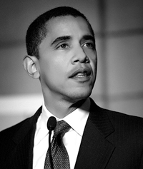
First, individuals who are opinion leaders, receive messages from the media and pass on their own interpretations in addition to the actual media content.
The information does not flow directly from the text into the minds of its audience, but is filtered through the opinion leaders who then pass it on to a more passive audience.
The audience then mediate the information received directly from the media with the ideas and thoughts expressed by the opinion leaders, thus being influenced not by a direct process, but by a two step flow.
This theory appeared to reduce the power of the media, and some researchers concluded that social factors were also important in the way in which audiences interpret texts. This led to the idea of active audiences.

Audience Theory 4: Active Audiences
This newer model sees the audience not as couch potatoes, but as individuals who areactive and interact with the communication process and use media texts for their own purposes.
We behave differently because we are different people from different backgrounds with many different attitudes, values, experiences and ideas.
This is the active audience model, and is now generally considered to be a better and more realistic way to talk about audiences.

Audience Theory 5: Uses and Gratifications Model
This model stems from the idea that audiences are a complex mixture of individuals who select media texts that best suits their needs – this goes back to Maslow’s Hierarchy of Needs.
The users and gratifications model suggests that media audiences are active and make active decisions about what they consume in relation to their social and cultural setting and their needs.
This was summed up by theorists Blumler and Katz in 1974:
‘Media usage can be explained in that it provides gratifications (meaning it satisfies needs) related to the satisfaction of social and psychological needs’.
Put simply this means that audiences choose to watch programmes that make them feel good (gratifications) e.g. soaps and sitcoms, or that give them information that they can use (uses) e.g. news or information about new products or the world about them.
Blumler and Katz (1975) went into greater detail and identified four main uses:
- Surveillance – our need to know what is going on in the world. This relates to Maslow’s need for security. By keeping up to date with news about local and international events we feel we have the knowledge to avoid or deal with dangers.
- Personal relationships – our need for to interact with other people. This is provided by forming virtual relationships with characters in soaps, films and all kinds of drama, and other programmes and other media texts.
- Personal identity – our need to define our identity and sense of self. Part of our sense of self is informed by making judgements about all sorts of people and things. This is also true of judgements we make about TV and film characters, and celebrities. Our choice of music, the shows we watch, the stars we like can be an expression of our identities. One aspect of this type of gratification is known as value reinforcement. This is where we choose television programmes or newspapers that have similar beliefs to those we hold.
- Diversion – the need for escape, entertainment and relaxation. All types of television programmes can be ‘used’ to wind down and offer diversion, as well as satisfying some of the other needs at the same time.

Audience Theory 6: Reception Analysis
Reception analysis is an active audience theory that looks at how audiences interact with a media text taking into account their ‘situated culture’ – this is their daily life. The theory suggests that social and daily experiences can affect the way an audience reads a media text and reacts to it.
This theory about how audiences read a text was put forward by Professor Stuart Hall in‘The Television Discourse - Encoding/Decoding’ in 1974 with later research by David Morley in 1980 and Charlotte Brunsden.
He suggests that an audience has a significant role in the process of reading a text, and this can be discussed in three different ways:
The Dominant or Preferred Reading. The audience shares the code of the text and fully accepts its preferred meaning as intended by the producers.
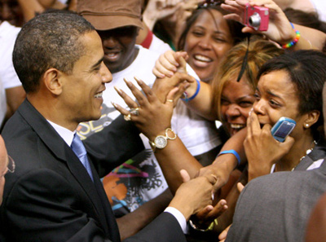
The Negotiated Reading. The audience partly shares the code of the text and broadly accepts the preferred meaning but can change the meaning in some way according to their own experiences.
The Oppositional Reading. The audience understands the preferred meaning but does not share the text’s code and rejects this intended meaning. This can be called a radical reading that may be, say Marxist or feminist or right wing.
It seems there is a lot to learn in this section about audiences but if you take it slowly it should all make sense.

Interactive Audiences
The interactive role of audiences in programmes where audience participation is asked is increasing.
Audiences are asked to be a voter (X Factor and Big Brother) or as an on screen member of an audience (Children in Need) or as a participant (Who Wants to be a Millionaire?).
This can be seen as audience power, but is it really? Sometimes the power of the audience seems to lie in being able to take part in a media text. Newspapers have always invited a reader response via letters, some of which are published.
Audience as producers Television has been a late starter in the participation stakes but is rapidly catching up. Not just with entertainment shows.
News is asking for CJs – Citizen Journalists - to send in pictures and stories.
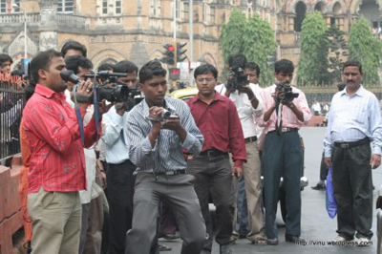
More and more documentary style programmes are made about so called ‘real’ people doing things that in the past would have been done by professional presenters – such as the Faking It series.
There are also the ‘make over’ programmes where ordinary people are invited to radically change their life with new clothes, new hair styles or by losing weight etc.
The audience is even more active than ever before. It is becoming part of the production. Audiences seem to like seeing themselves on any genre of programme except drama – from daytime confrontational help programmes (Trisha, Oprah) to Diet Doctors.
What sort of TV programme would you like to see yourself on?
Twenty first century audiences are creating their own distribution systems without mediation from institutions or companies. Websites such as My Space, YouTube, and blogs offer new possibilities for audiences.
In fact it is what we do and what we spend our money on that gives an audience its value, and to some extent its power, not just what we watch. Things that influence audiences include new technologies.
For example the way broadband and the internet has reduced TV audiences. Digital transmission and production means there are many new channels and ways of viewing media texts not just on television but also via the internet.
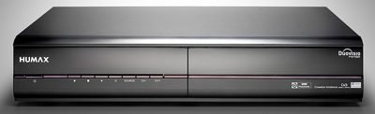
The internet has opened up new ways to receive and interact with information. We can ‘read’ texts that are downloaded to our computers, or held on a hard drive PVR – Personal Video Recorder not just when the broadcasters want us to receive it, but 24/7. There is however always a cost to this.
It is vital that any student of media understands the importance of audience not only theoretically, but as the target audience for any own media production.
http://youtu.be/DwbB02-rCVw

