How conventional is the narrative structure of your chosen texts?

EXEMPLAR WJEC MEDIA STUDIES MS4 - L4 RESPONSE

Industry chosen: Film

Texts:

Harry Potter and the Deathly Hallows - Part 2 (2011) – UK/US

Sket (2011) – UK

Sin Nombre (2009) – Mexico/US

My three key texts are Harry Potter and the Deathly Hallows Part 2 (2011), Sin Nombre (2009) and Sket (2011) as examples of films that have both conventional and unconventional narrative structures (up to a point).

HPDHP2 is part of an eight film, critically and commercially successful fantasy genre franchise, completing in 2011 and based on the novels of J.K. Rowling. All distributed by Warner Bros. they suggest a more mainstream approach to narrative and story development – the characters of Harry, Hermione, Ron, Lord Voldemort, Ginny Weasley, Bellatrix Lestrange, Severus Snape and Hagrid would all be familiar to audiences as would the actors themselves, many of whom have become iconic household names. HPDHP2 links directly to Part 1 in terms of narrative and characterisation; the opening scene shows Harry, Hermione and Ron at Dobby’s graveside but with dialogue enabling the first time viewer to develop an understanding of plot lines and development. Audience cultural capital, in terms of understanding the books and entire film franchise would ensure deeper readings.

As a Hollywood distributed film however, the film follows a traditional three act narrative structure – act one sets up ‘the problem’ as characters, settings and issues for narrative development are established. This is firmly anchored by the second scene in the film which expands the storyline to create a unique selling point; the searching for and destroying of the seven Horcruxes. Narrative enigma is planted at this stage with audiences asking questions of initial conversations between Griphook, Harry, Ron and Hermione (Harry, Ron and Hermione are still the key protagonists) at their familiar safe house, beach sanctuary. This relates to what may be in Bellatrix’s vault at Gringotts Bank and the role of the Sword of Gryffindor. Drawing on narrative arcs with previous storylines, Voldamort is set up as key antagonist.

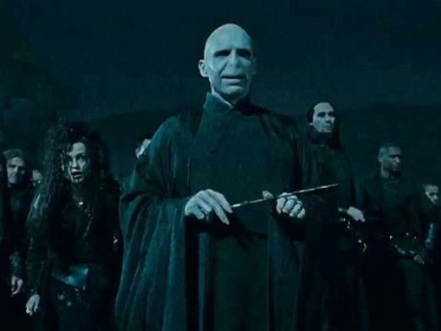

At this stage Propp’s narrative theory of eight character roles can be easily applied to the film with Neville Longbottom as ‘helper’ leading the trio through to a secret passageway into Hogwarts and ultimately decapitating and killing the seventh Horcrux, Voldamort’s pet snake Nagini – this leaves Voldamort mortal and able to be killed by Harry. A clear ‘villain’ and ‘hero’ are represented by protagonist and antagonist Voldamort and Harry while Hermione could represent the ‘princess’ with metaphorically ‘her father’ being Ron who fiercely protects but also empowers her throughout the film. Dumbeldore, as a ghost in dream sequence fills the role of despatcher in giving Harry a choice but also sending him on his way to complete his quest (a classic narrative convention underpinning Fantasy and also Action Adventure genre films). Snape it is implied is responsible for the Sword of Griffindor suggesting a ‘donor’ role (the hero has a magical tool that will help him complete his quest) while Griphook emerges early on as a ‘false hero’, taking the sword from the trio and double crossing them leaving them in he bank vault.

The role of Hogwarts as a key iconic setting is clear early into the film which is anchored by the lengthy final scenes taking place in and around the same elaborate, built set. A multi stranded narrative, with sub plots is evident but always allowing audiences the pleasure of understanding a main, single stranded narrative thread of destroying the Horcruxes and with it, Voldamort. Multi stranded narrative devices are character and object based e.g. Harry speaking to Helena Ravenclaw’s ghost, the role of the Basilisk fang but crucially the role of Severus Snape as new headmaster of Hogwarts. Asynchronous (use of flashback) narrative techniques are used to connect Harry to Snape, showing Snape as a young boy with Harry’s, presenting him in a more positive light anchoring the key scene of Snape’s death at which Harry is present – Snape enables Harry by telling him to take his memories to the Pensieve, a stone basin used to store and review memories present and is a familiar object from previous films.

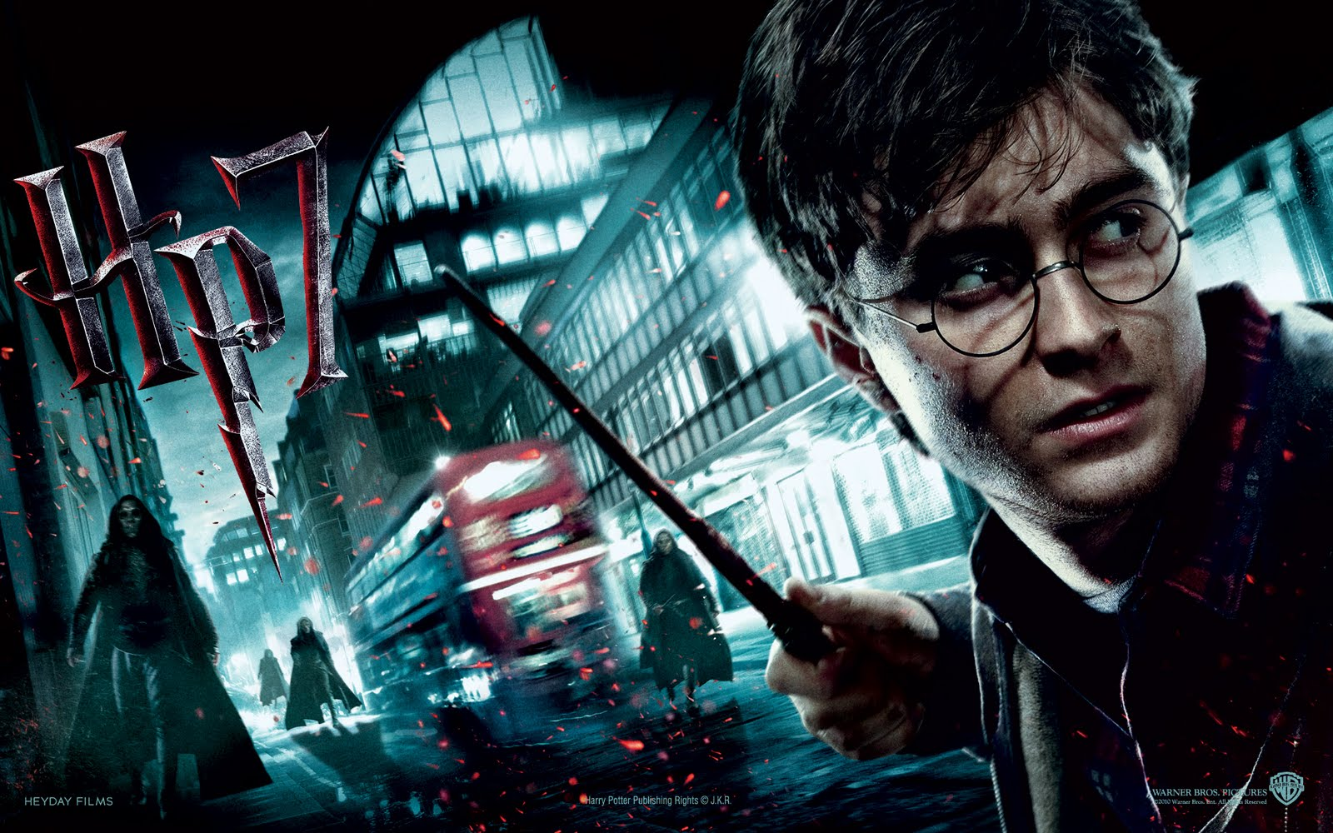

Although narrative action codes are often predictable and inevitable they are mixed with enigma and extended to ensure the spectator is still asking questions of the film to the end – Harry as the eighth Horcrux, accidentally made by Voldamort becomes apparent while the ‘death’ of Harry is a narrative shock technique for audiences. Following mainstream, narrative fantasy conventions this is one of many twists for audience who seek answers as to why Harry has to die (to destroy the last piece of Voldamort’s soul). Notions of self-sacrifice as a narrative theme are embraced by the storyline as Harry goes to die at the hand of Voldemort in the Forbidden Forest but only to find the spirit of Dumbledore after his ‘death’ telling him he is able to return and defeat Voldamort once and for all.

As part of a conventional closed narrative structure, villain is defeated, Ron and Hermione reconcile their feelings for one another and a three act narrative is complete. Todorov’s four act structure can also apply in the closing scenes but representing a new equilibrium as nineteen years later audiences see Harry and Ginny’s, Ron and Hermiones’ and Draco and Astoria Malfoy’s children leaving for Hogwarts from the culturally British landmark of King’s Cross Station, remaining faithful to the literary origins but also allowing for the outside possibility of a sequel.

Section A - Representation areas of study:

- Representation of age (active key protagonists), with wisdom embodied by older male characters.
- Representation of English national identity – Hogwarts is reminiscent of a traditional English public school, anchored by accents and dialogue (John Hartley – genre is interpreted culturally).
- Representation of gender – dominant male villains battling with a ‘geeky’ but magical central protagonist in Harry. Hermione as in constant need of rescuing.

Section A - Genre areas of study:

- Classic conventions of the fantasy genre evidenced by narrative and mise-en-scene.
- Hybridisation with the action adventure genre – the narrative involves a journey or a quest.
- Issues of intertextuality and cultural capital relating to prior films in the franchise.
- Genre marketing and mass/mainstream audiences – UK/US collaboration underpinned by Warner Bros. financing and distribution.
- Repetition and difference (Neale).
- Safe genre – audience expectations and commercial success (Jason Mittel – industry uses genre commercially).
- John Fiske – genre is a ‘convenience’ for producers and audiences.

Section B – areas of study:

- Audience appeals/pleasures including Fantasy genre conventions – high production values, feel good narrative, representations of youth (mirroring the audience), convergence and synergy (multi platform availability and video game), emotive narrative, CGI, aspirational, escapist characters, simplistic linear narrative with understanding narrative arcs a pleasure for fans of the franchise, magic, mystical creatures and pure escapist entertainment.
- Marketing and Distribution – the role or Warner Bros. as financier and distributor, notions of US/UK collaboration (British cultural representations), genre marketing through fantasy conventions, franchise familiarity but with USP and ‘darker’ narratives, familiarity with characterisation (household names), linking with literature (the ‘presence’ of J.K. Rowling on marketing literature, posters and publicity).
- Globalisation – although culturally British the film has been globally distributed and through convergence and synergy is familiar to audience worldwide. American appeal though British cultural representations.
- Digital Technology – CGI and SFX associated with high production value, fantasy genre films, multi platform availability, synergy with computer game (graphics and mise-en-scene), multiple camera technology, post production conversion to 3D e.g. deep 3D in the Forbidden Forest, the effect of 3D on the narrative….
- Regulation – link with genre and youth audiences (moderate threat only – BBFC 12a) but parental complaints that the film is dark and disturbing, more so than previous films, hype leading the film’s release that it would have a higher certificate (used in the marketing), representation of death and torture in key scenes.
- Star Marketing – role of J.K. Rowling in promoting the film, Daniel Radcliffe and Emma Watson ‘growing up in public’, generic typecasting and secondary persona (Dyer), Ellis – ordinary and extraordinary, constructing a star through a long running franchise, the role of existing, established stars in anchoring the narrative and justifying the saturated distribution by Warner Bros. – Ralph Fiennes, Helena Bonham-Carter, Robbie Coltrane, Warwick Davies, Michael Gambon, Gary Oldman, Alan Rickman, Maggie Smith and Julie Walters (familiarity with mass, mainstream, US/UK and global audiences).

Sket presents audiences with a gendered female, revenge narrative focusing almost exclusively on female protagonists with the exception of Ashley Walters who audiences with cultural capital would identify with from Bullet Boy (2004). Both films are urban, social realist thrillers hybridised with the gangster genre with the former So Solid Crewe front man playing a gangster on both occasions, with a similar fate – his violent death. Settings are important also in terms of audience with many wide-angle night shots identifying the city of London but also the deprivation of the sprawling Rowley Way Estate just north of Camden. The narrative introduces a niche audience to familiar narrative themes common to the social realist and gangster genre of loyalty, revenge, family values, isolation, belonging and male violence and has culturally British representations independently produced and distributed by Gunslinger and Revolver Entertainment. Arguably its niche, regional distribution allows for what some would see as an unconventional narrative only in extent of the female representation.

The title of the film gives additional connotations relating to a dirty girl who sleeps around and the two sisters - both Kay (Kayla) and Tayna are initially represented in binary opposition to Danielle and her gang. In the opening title sequences, girl gang violence is firmly established with Kay initially seen as a female victim as she walks through the estate. Tayna is her protective, older, more sensible sister. Narrative themes of historical male violence and weak mothers are developed earlier on in back stories about Kay who refuses to see her father (her mother is dead) and in Danielle and Hannah whose mother’s have also died and Danielle’s historical experience of male violence which is used to part explain her own controlling, violent personality – she states” “We don’t want to end up like out mothers”. Narrative development spirals downwards after Trey kills a crack head who is behind on her payments to Trey who Shaks finds in his ‘office’ – the dysfunctional relationship between Trey and Shaks is further anchored by his strangling of Tayna in front of her as punishment for her weakness and also his desire that Shaks’ unborn child is killed.

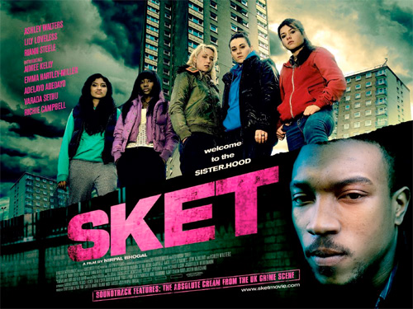

Female victims litter Sket but so do empowered, female protagonists. Kay want to belong and be a part of Danielle’s gang but underpinning this sense of aspiration is a sense of sexual tension from Danielle in relation to Kay who she rescues from male violence on two occasions. Shaks and Trey are both more traditionally glamourised as powerful, traditional gangster and gangster’s moll but this characterisation is slowly challenged by Kay and Danielle’s gang who attack and kill Trey after Kay cannot. Interestingly however, in terms of narrative outcomes Danielle kills Trey but is stabbed herself after going to Kay’s rescue yet again anchoring the feelings Danielle has for Kay – her gang are also surprised after Trey makes misogynistic comments about her sexuality as it transpires he raped her when she was 14.

Frequent shots of the estate and skyline remind audiences of the spiral of deprivation but there is arguably an aspirational aspect to the narrative despite the bleak, narrative outcomes. A fast paced, non diegetic urban soundtrack only at times appeals to an urban audience familiar with the film’s representations and in a similar way Kidulthood approaches the exploration of key social issues - sometimes these narrative themes and social comment are lost in the hybridisation and need to entertain a target audience. The narrative is shocking and violent at 15 certificate and focuses on female violence, but crucially in response to, and as a result of historical and current male violence through the controlling character of Trey – Shaks chooses in the end to remain loyal to him and not drug his drink but she cannot protect him and after his death she is seen as more vulnerable and in need of protection. The film is developed in three acts and is linear and single stranded but making intertextual reference to many other social realist films offering hope and redemption in narrative closure as Kay finally reconciles herself to her father after the villain is defeated.

Section A - Representation areas of study:

- Gender representation and notions of similarity and difference – key focus on female central protagonists and characters (represented and both empowered and vulnerable) but all beholding to a dominant, male character.
- Challenging and reinforcing traditional representation of gender – pluralism v hegemonic cultural stereotyping.
- Representation of family and family values – the concept of the weak mother and weak father explored through the narrative linking with representation of age.
- Representation of urban culture and national identity – dominant and oppositional readings.
- Representations of regional identity – north-east and London, notions of ‘belonging’.

Section A - Genre areas of study:

- Hybridisation of gangster thriller and urban social realism offering audiences a ‘set of pleasures’ (Rick Altman).
- Familiarity with genre conventions – hyper real gang violence, swearing, drugs, bleak urban mise-en-scene, settings, dress code….
- Genre intertextuality and issues of cultural capital – audience familiarity with Kidulthood, Bullet Boy, Ill Manors, Shank…..
- Repetition and difference (Neale) linking with gender representation.

Section B – areas of study:

- Audience appeals/pleasures including audience identification with urban representations, cathartic violence, certification (promises of pleasure), aspirational female characters, star marketing of Ashley Walters, fast paced urban soundtrack, revenge narrative, intertextual linking with other social realist, urban thrillers, British cultural representations, narrative themes (older target audience), voyeurism and escapism.
- Marketing and Distribution – niche, independent distribution, regional aspect to the marketing of the film, marketing linking with other urban thrillers e.g. Bullet Boy and Kidulthood, representations of youth culture important in selling the film, USP of female gang violence, limited distribution and typical to the pattern of low production value British films in that the theatrical release is almost a platform to market the film online and via DVD sales.
- Globalisation – construct an argument to explain why this is not a global film; niche cultural representations, exploration of non aspirational, bleak youth sub culture, negative narrative outcomes, low production values, made with a regional demographic in mind (no intention of a theatrical release outside of the UK)….
- Digital Technology – again, compare the lack of high production value, digital technology to HPDKP2 linking with distribution, narrative and audience but shot using hand held digital cameras, available as a download, the role of YouTube in generating viral hype.
- Regulation – controversy and complaints about violent scenes, drug taking and mimetic behavior (copying), BBFC justification in 15 certification as reflecting desensitisation and deregulation, cut away shots avoiding showing the violent death of Trey, issues of aspiration and passive consumption linking to Kidulthood and audiences ‘enjoying’ the film too much and ignoring the embedded narrative themes.
- Star Marketing – role of Ashley Walters in marketing the film to an urban demographic, Lily Loveless as Hannah (audience with cultural capital would recognise her from Skins) but importantly a lack of star marketing linking with more realist representations.

Sin Nombre is a US/Mexican hybridised, independent thriller with social realist elements that offers a conventional, but multi stranded narrative based on character and character relationships. On one level the film is single stranded in that an ex Mexican gang member is fleeing for his life and meets a Honduran girl who is trying to travel to America but the storyline is based on a series of connected events that bring them together. The film intercuts between two distinctly different storylines – the ‘bad’ MS-13 Mexican gang represented by their leader Lil Mago, completely lacking in morals and brutally violent (he tells El Casper he “will find another” after accidentally killing his girlfriend) and the poor, honest Honduran family represented by Sayra, her uncle and brother.

Key protagonists emerge within the Mexican gang with audiences introduced initially to El Casper and the young Smiley who is initiated into the gang via a vicious beating and a first kill (which importantly allows him to kill again, his friend El Casper). Martha acts as a catalyst to narrative development and provides the disruption as she wanders into the gang’s meeting in a graveyard, is escorted out by Lil Mago who attempts to rape her and who is accidentally killed while attempting to escape (she falls and smashes her head on a rock). Settings are important in establishing narrative themes of poverty, illegal immigration and desperation – to anchor verisimilitude many of the extras sitting on top of the train in La Bombilla were actual migrant workers. The mise-en-scene shows a bleak, crowded, dirty and dangerous railway siding, littered with illegal immigrants seeking passage to the US. This is juxtaposed with wide shots of the beauty of the agriculturally rich Tapachula countryside in binary opposition to urban squalor and the danger it represents.

Within the story further narrative themes are evident, in terms of audience expectations of independent productions like Sin Nombre – male violence, a recurring theme in Mexican films like Amores Perros is explored through the gang members and linked to additional themes of loyalty and belonging (the initially innocent Smiley kills his friend Casper to remain as part of the iconic, global gang). Smiley feels his life is underpinned by the male ‘family’ of the gang, and that this is something to be valued. While Martha is the classic female victim to this male violence Sayra is empowered and applying Todorov’s four act structure the film suggests a new equilibrium or new beginning for her as she telephones her father’s new family from outside an American mall. Intercutting reveals again a new beginning, albeit perceived as negative for Smiley as he is seen in extreme close up having his bottom lip tattooed ensuring audiences are aware his future is likely to be violent,, with negative consequences.

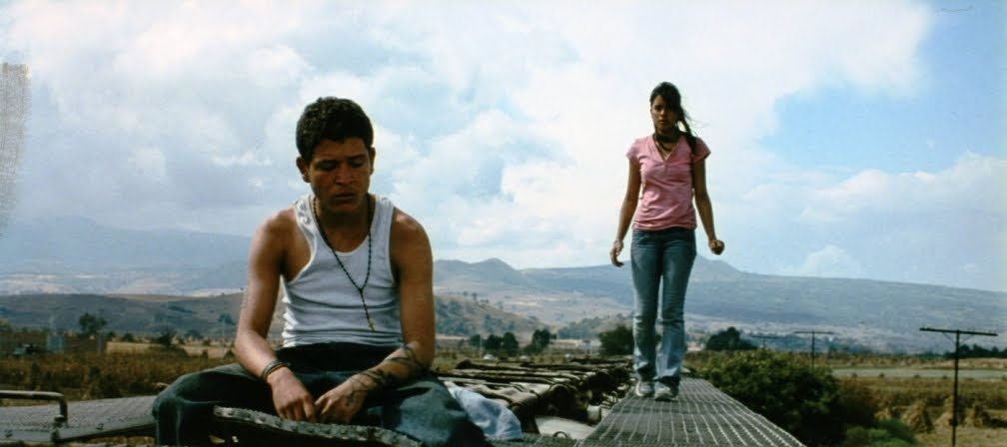

A pivotal narrative event gives the film a more positive direction after El Casper machetes and kills Lil Mago on top of the train as he is about to attack Sayra and her family – this gives El Casper and the film a new moral direction as he (Casper) turns his back on his violent past and embraces the ‘good’ of Sayra and her values although ultimately he is punished for his disloyalty to the MS-13. A romantic sub plot develops between Sayra and El Casper after she saves him from the migrants who try and kill him. The mise-en-scene again anchors this positive representation as he sees the migrants cooking, washing and existing as a family together; close ups on food, babies’ faces and the normality of a community living together persuades him that he wants to embrace his new life. Interesting this parallels Lil Mago’s misogynist comments as he does indeed “find another”. El Casper’s new found morality is shown in the penultimate closing seen on the riverbank American border with his insistence that Sayra swims first with her coyote leading to his own death as the gang find him (previous to this he had comforted her in a chapel after she is told her father and uncle are dead).

Narrative themes of the end of innocence are represented by Smiley’s killing of El Casper with the young boy as ‘promised to the devil’ and Sayra in the ‘promised land’. From the equilibrium and disruption of the opening scenes showing the MS-13 gang and their activities, Sin Nombre follows a linear journey, both metaphorical and physical. This represents the characters’ moral journey (in particular El Casper) and Sayra’s physical journey to freedom ending in an open ended new equilibrium where the future for both Sayra and Smiley is imagined in mind of the audience.

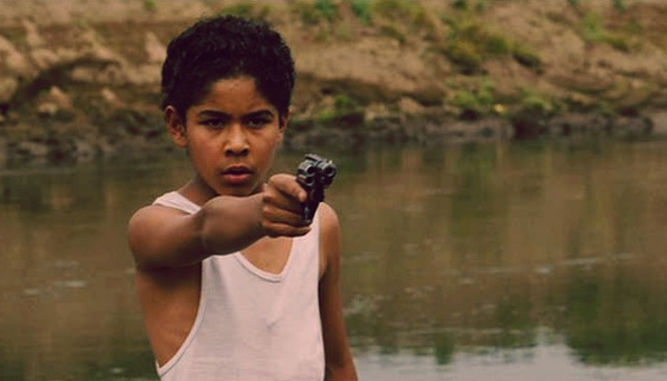

Section A - Representation areas of study:

- Representation of hyper real, male violence.
- Issues of misogyny and macho male culture juxtaposed with female empowerment.
- Representations of youth and the concept of ‘innocence’.
- Representation of national identity – Mexico, Guatemala and Honduras as representing third world poverty in binary opposition to American Dream ideology (Richard Dyer – stereotypes legitimise inequality).
- Representation of youth and gang culture (Taijfel and Turner – intergroup discrimination and stereotyping).
- Sin Nombre as both challenging and reinforcing ethnic stereotyping.

Section A - Genre areas of study:

- Hybridisation of genre conventions – thriller and social realism (Henry Jenkins – evolving hybridisation).
- John Hartley – genre is interpreted culturally (elements of social realism decoded by audiences but also issues of entertainment).
- Narrative action points and violent events as key convention of the thriller.
- Thrillers as often having a more complex storyline than traditional action films – Sin Nombre as encoded with action and enigma.
- Genre iconography familiar – urban deprivation but also guns, weapons, tattoos…

Section B – areas of study:

- Audience appeals/pleasures including emotive narrative, characterisation, escapism and voyeurism (‘other’ cultures), patriarchal gang violence and action sequences – younger audiences, 15 certification (promises of pleasure), exploration of narrative themes linking with a primary and a secondary target audience, use of narrative enigma, genre conventions.
- Marketing and Distribution – limited distribution and ideas of ‘world cinema’, niche audiences, marketing presented the film as a violent thriller (posters, trailers, DVD jacket all has shots of guns and weapons) but also allowed an older demographic to pick up on narrative themes of illegal immigration, human trafficking, gang culture, poverty and economic dependency, critical success used in marketing (prizes for directing and cinematography at the Sundance Film Festival), extensive linking in marketing to the Mara Salvatrucha gang (‘S’ in Sin and ‘M’ in Nombre links directly, title also used in marketing as creating narrative enigma.
- Globalisation – although not globally distributed the criminal gang that is so foregrounded in the narrative originated in LA but spread to the US regions and states, Canada, Mexico and Central America and have a global reputation as being merciless and brutal (through crime reporting), American cultural imperialism and American Dream ideology is a key feature although the film is set in south and central America, to UK and US audience the film would be representing an unfamiliar global culture linking to potential voyeurism.
- Digital Technology – available digitally via download and streaming after a limited theatrical release, limited use of technology to encode verisimilitude.
- Regulation – again, the usual complaints about degrees of violence and sex, sexual violence and the BBFC certification at 15 (particularly a young approx. 12/13 year old boy in Smiley committing two murders, one coerced but another with full independence and understanding of consequences), fears of passive consumption linking with scene of Smiley bragging to his peers about the fact that he is now in the gang, use of children in the narrative created further controversy as Lil Mago is in several scenes seen holding a young baby, again issues of audience desensitisation leading to deregulation.
- Star Marketing – use of previously unknown (El Casper) and Mexican child actors (e.g. Smiley), authenticity and legitimacy to narrative by use of extras who were actually migrant workers, the lack of star marketing encourages audiences to engage in the narrative and understand notions of realism and decode narrative themes.

