Explore the ways in which your chosen texts reinforce or challenge typical representations of gender?

EXEMPLAR WJEC MEDIA STUDIES MS4 - L4 RESPONSE

Industry chosen: Video Games

Texts:

Tomb Raider (2013) - US

GTAV (2013) - UK

BioShock Infinite (2013) - US

My three key texts are Tomb Raider (2013), GTAV (2013) and BioShock Infinite (2013) as examples of action adventure and first person shooter games that both challenge, and reinforce cultural stereotypes of gender.

Issues of audience cultural capital with Tomb Raider are crucial in understanding historical and contemporary representation as a franchise first developed and published by Eidos in 1996, critically and commercially successful involving games, films and books – Tomb Raider was, and is a mainstream text and as such has a mass audience who have expectations in terms of the representation of gender. Lara Croft in Tomb Raider (2013), which still has a predominantly male demographic acknowledges however the growth in female gamers – Lara is less curvy (her breast are significant but smaller), she is more muscular, has more ‘personality’ and gone are the short shorts and mid-riff.

Lara initially appears as an isolated female victim as the ship she is travelling on, The Endurance breaks in two – she show fear which is a departure from previous versions of the game. Her physical strength and resourcefulness develops as she sets out to find, and save her travelling companions. The game player controls Lara in third person as she battles the Solarii Brotherhood and Mathias on Yamatai – the enemy is gendered male and Lara Croft uses her stereotypically gendered masculine skills with guns, a bow and arrow but also her physical strength and ability to survive significant punishment and adversity. She is no longer and out and out killing machine.

Mapping Angela McRobbie’s theory of the post feminist icon, Lara Croft’s challenging representation as the strong female protagonist suggests that she is positioned to be understood by audiences in this way – she exhibits the stereotypical characteristics of a male action hero in her physical dominance, courage and resourcefulness but also is sexualised and framed for Mulvey’s male gaze; her breasts and cleavage are still always deliberately visible in gameplay whether flying through the air on a zip-line or rope or lying on the ground. Using Stuart Hall’s theory, an oppositional reading could be that far from suggesting her post feminist status (where sexualisation is normally controlled by the character herself) she is fact simply objectified for predominantly male game players enjoying controlling her objectified representation in the third person.

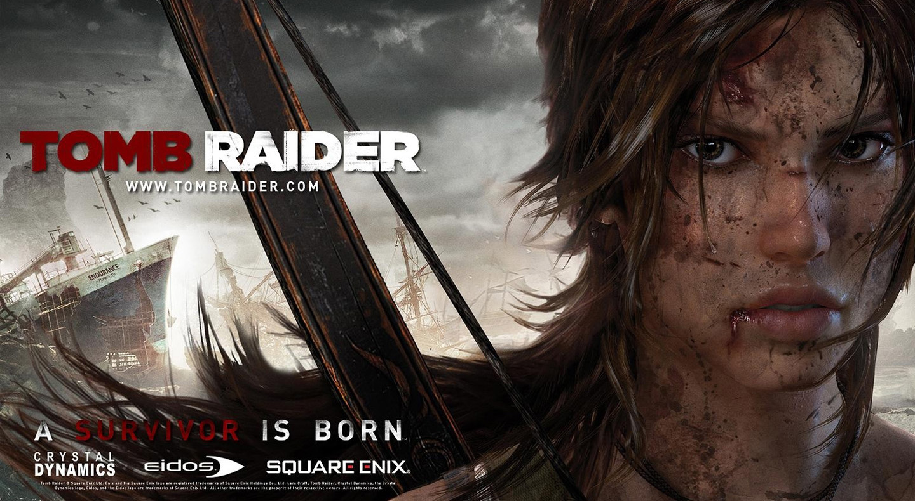

The choice of casting an English middle class actress in Camilla Luddington who played Kate Middleton in William and Kate ensures her initial fragile vulnerability as a naïve, young ambitious archaeologist is anchored (her voice has soft tones). This develops in binary opposition as you see Croft early on in the game pull a shard of metal from her side and then continue on to find her companions, who in terms of gender representation reflect a range of stereotypes – Dr. James Whitman is the weak, male leader of the expedition who Croft defies but she is protected by a patriarchal mentor in Conrad Roth, an ex Royal Marine but this traditional representation is challenged later on in gameplay when he is injured and she looks after him.

Croft’s relationship with Sam and Joslyn is interesting with Joslyn as a temperamental mechanic and single mother but with Sam, a Japanese friend of Lara and member of the funding Nishimura family as also sexualised and seen as in need of saving by Lara – this develops notions of ‘the female exotic’ through Japanese locations and character (the publishers, Square Enix are also Japanese). Comedic male representation is in the guise of Angus, ‘grim’ Grimaldi, the rough Glaswegian helmsman of the Endurance and the geeky Alex. Female representation also extends to the island itself as once ruled by a Sun Queen, Himiko.

Fast paced physical action sequences and combat underpin the representations with an iconic Lara Croft identifiable again when she kills Mathias with her trademark double pistols with their arguably phallic connotations. From feeble lines like “I’ve just got to do this” and her initial capture (by a man) through to more confident statements like “we find something that keeps us going” Croft moves from a hegemonic representation into a more culturally influential pluralistic central character in the new game who subverts the gendered rescue narrative and offers a more challenging representation.

GTAV however, is manifest in its sexism and misogyny regarding the representation of gender. As a massively commercially successful game (fastest selling of all time) it is published by Rockstar North who are known for their hyper real male representations and representing male violence in games like Red Dead Redemption and Max Payne. In GTAV three morally corrupt men in the fictional Los Santos practice stubborn sexism that fails to recognise, or hold up and form of mirror on society, choosing instead to reinforce typical representations of gender and prejudice and maintain unequal gender divisions encoding a dominant patriarchal ideology.

Crucially, the game is played predominantly by a young, male demographic (with a limited but relevant female audience) who enjoy the escapist representations – the key issue is whether issues of passive consumption are relevant in terms of gender. Players have commented on YouTube, in regards to a sexually violent feature of the game where prostitutes can be punished or killed: “I sometimes enjoy just running ‘them’ over, I only run them over in a sports car – gotta stay classy”. The mainstream, mass audience are crucial in understanding the exaggerated representations in the game, acknowledging that a key appeal is violence, guns and women.

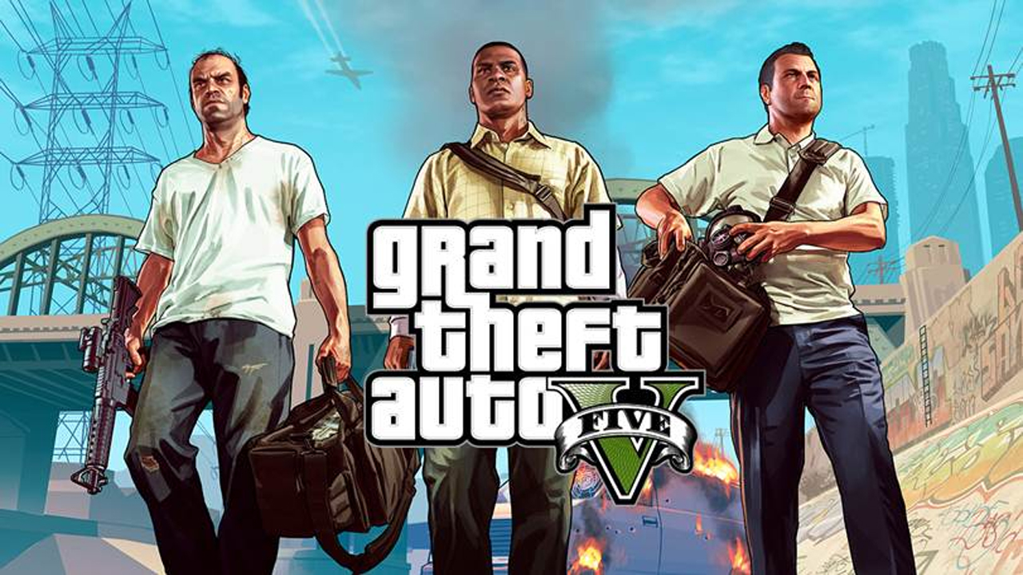

The stereotypical settings anchor the representations in the game including strip clubs, bars and swimming pools with women not only sidelined but also wholly objectified for the male gaze as objects of desire. Negative reactions to Carolyn Petit’s review of GTAV as sexist in Gamespot reflect the loyal target audience who fail to see the game in this way – the only women in the game fulfill the traditional, hegemonic cultural stereotype as strippers, prostitutes, unhappy wives and nagging girlfriends. Attempts are made to almost justify Michael’s misogynistic behavior in gameplay as he finds his wife Amanda in bed with her tennis coach (although they do reconcile later on). Compounding this you still cannot play as a female character – the game represents an outmoded ‘boy’s club’.

Using an oppositional reading, Trevor, Michael and Franklin could almost be symbolic caricatures of a declining brand of masculinity that reflects more of a fragmentation of gender identity in society – David Gauntlett would argue this form of collective identity is no longer relevant (the boy’s club) and that representation of men and women are as hyper real and ironic as each other. Amanda constantly bickers with Michael regularly name calling him a “selfish dick”, and “worthless turd” encoding humour into the representations while jogger Mary-Ann, one of the few female quest drivers constantly challenges and mocks Michael and is aggressive herself. A weak male character however, in the IT expert Lester Crest is deliberately represented as emasculated to ensure the main protagonists remain dominant.

It can be argued that a female character who challenges the typical representations is Talianna Martinez who in gameplay you find by the roadside and as she gets into your car she tells you her story – as a getaway driver she was attacked by her partner in crime but they crashed and “he got what was coming to him” suggesting a form of female empowerment up to a point. During gameplay players can make her a driver for future heists with high stats but perhaps importantly, she will work for less money. Aunt Denise enjoys female empowerment but Franklin does what he pleases.

Petit argues against this by suggesting that the overriding theme is still patriarchy (as with all previous versions of the game) with ads during gameplay persuading women to “purchase a fragrance that will make them ‘smell like a bitch’ and radio reports discussing using a woman as a urinal – extreme use of language, including homophobic references and representation of race and ethnicity through the character of Franklin is relevant in understanding the representations in GTAV. It is intentionally politically correct because hyper masculine games sell as a form of acceptable or unacceptable entertainment.

BioShock Infinite, in comparison to Tomb Raider and GTAV is a wholly non realist FPS game encoded with science fiction conventions affecting the reading for the representations – the game has a female rescue narrative with the main character, Booker DeWitt a stereotypically male anti hero, ex Detective/Agent who is sent to the fictional floating city of Columbia to rescue Elizabeth, a young woman who has been imprisoned there since childhood. 1912 Columbia is run by the elite ‘Founders’, Father or Prophet Comstock who bases his powers on the cult of personality influenced by the Founding Fathers of the United States – in gameplay this historical, embedded patriarchy is continually referenced through American flags and shots of statues of ‘Father Washington’ and ‘Father Jefferson’, ex US Presidents.

The patriarchal narrative voice over of DeWitt anchors the male rescue narrative but Elizabeth is far from passive – she is initially framed as vulnerable and in need of rescue from the evil Songbird who has held her captive on Monument Island but as they flee, Elizabeth leads the way and DeWitt follows. The two central protagonists are deliberately placed in binary opposition with Elizabeth seen as logical and resourceful (she works out the route, gives DeWitt guns and ammunition) but in need of male protection and male violence in the form of DeWitt. Her femininity and fragility is reinforced on occasion in gameplay when Elizabeth disappears because she wants to listen to music she is hearing and also utters lines like “I want a puppy”.

BioShock Infinite is also a commercially and critically successful game targeting young, male gamers which inevitably will suggest more traditional, typical representations – the object of the game is to “bring us the girl and wipe away the debt” (his gambling debt) as DeWitt is dropped at an island lighthouse at the beginning of the game, enabling him to take off in a rocket silo to Columbia. However, as the game progresses we discover that the character of Elizabeth is also empowered with the ability to open up Tears affecting the direction of the game. This very much suggests that although she appears as the female victim, the game has a dominant reading of patriarchy or a negotiated reading which places Elizabeth in a much more pivotal role than her manifest representation suggests.

Players find out later in gameplay that she has been brought up as the adopted daughter of Founder Prophet Comstock and in a bizarre narrative twist in one direction open to the game, that she is in fact DeWitt’s own biological daughter. This then bestows added value on the female rescue narrative, as he is not only the patriarchal protector but also her parent. They seem close throughout gameplay and regularly talk to each other as she ‘directs’ their journey. His role is almost exclusively to kill and protect her in combat. Towards the end of the game Elizabeth also kills (once only) which is a pivotal moment in her physical representation – she knifes Daisy who heads up the Vox Populi, the movement in opposition to the Founders because she was going to kill a Founder boy (Elizabeth displays stereotypical maternal instincts throughout the game). She then flees after the killing with DeWitt and boards an airship to escape to New York or Paris.

Once on the airship Elizabeth lock herself in a room as DeWitt pilots the airship and takes off but emerges in an overtly sexualised outfit emphasising her breasts and curves claiming: “it was the only thing they had” (she had Daisy’s blood all over her clothes). This scene, by implication has connotations of rites of passage into womanhood through her first kill as DeWitt comments on her very different representation from the prior much more conservative dress code (but still displaying her stereotypical feminine lines). BioShock Infinite on one level challenges typical representations of gender but regularly repositions characters into a more patriarchal sphere.

Additional work on representation, including other areas of study - ethnicity, national identity and age:

TOMB RAIDER

A female player’s perspective:

“Oooooooh, awesome!!! The new one is AMAZING! I think it’s much less sexist and it portrays Lara in a realistic way. She really struggles at the start and you can tell she’s constantly terrified of what’s happening to her in the game. She shows a lot of emotion and she’s not got massive triangles boobies too lmao. It’s defo much more of a realistic approach to Lara compared to her in past games – she has a strong personality and I actually felt bad when she got hurt in the game if I messed up cause it looks and sounds really awful! She’s very easy to connect with in terms of her fear, she’s not an out and out killing machine with no personality and just boobs haha”.

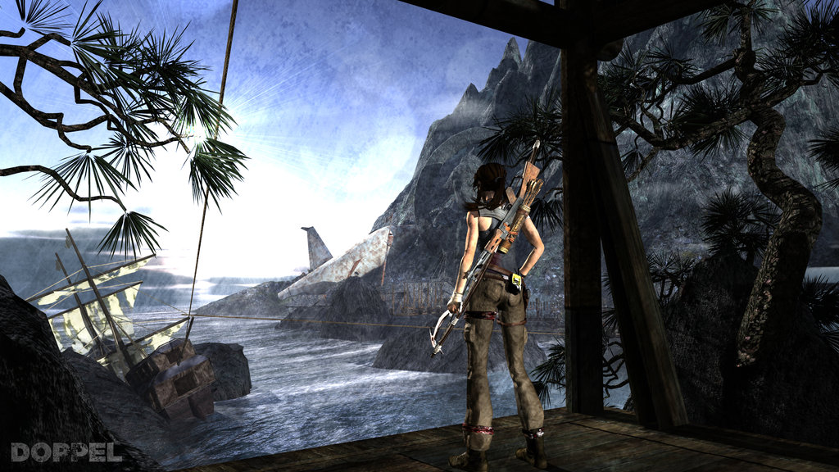
- Representations of ethnicity could be explored through the character of Joslyn and her role in the gameplay narrative as the only non-white character. She is represented as a single mother who is also a mechanic.

- Representation of age could also be developed though the naïve but empowered youthful representation of Lara Croft as a young explorer who seeks fame as an archaeologist. She defies her older expedition leader and ultimately saves her older mentor Conrad while also seeing as her priority to save her age contemporary, Sam.

- National identity is a key area in Tomb Raider that can be discussed on a number of levels – Lara Croft is an English, middle class archaeologist who seeks adventure and is played by an English middle class actress in Camilla Luddington who was schooled in America and arguably has a mid Atlantic hybrid accent. This would open up her representation to a wider audience in terms of recognition. Japanese national identity can be developed using a range of references – the owners and publishers of the game are now Square Enix but it is the exotic Japanese setting of Yamatai that can be analysed in some depth (Yamatai is the Sino-Japanese name for an ancient country that Japanese historians and archaeologists have debated for many years). How the island is represented would be a relevant debate along with the role of Sam and how relevant her own Japanese background is as a member of the wealthy Nishimura family.

GTA V

- Representations of national identity in GTA V give players the opportunity to explore the fictional city of Los Santos in the fictional state of San Andreas (modeled on southern California) which is a metaphor for L.A. – the city is seen as glamourous and aspirational potentially leading to debate on American Dream ideology (Michael, Trevor and Franklin choose to achieve their goals at all costs). Significant research went into creating a similar layout and representation to L.A. but it is the underbelly of American crime and gang culture that is fore-grounded.

- In terms of age, youth is seen as aspirational which is what the three men have lost – they are in their late 20s (Franklin), early 30s and late 30s (Michael and Trevor). Their behaviour reflects their refusal to settle down to any form of normality more representative of people of their age. They feel the need to constantly rebel which could be linked to the target audience appeals and audience pleasures.

- Michael is the only non-white protagonist and his ethnicity and black American lifestyle is subject to cultural stereotyping through his use of language and mise-en-scene (his black friends like D are often thugs). He works as a Repo Man for an Armenian luxury car dealer and notions of a multicultural American city are frequently explored in the game.

BIOSHOCK INFINITE:

- American national identity is wholly relevant to BioShock Infinite – set in 1912 at a time of American Exceptionalism the theory suggests that America is qualitatively different from other countries, a form of cultural imperialism and superiority. American flags predominate throughout gameplay and the ‘new world’ is seen as an idealised place to live and economically thrive. American Presidents underpin the Founders’ philosophies with the name Columbia being the historical and poetic name used for the US and is its female personification (see WW1 patriotism poster). Analysing representations further, nationalism can be decoded not least in the family link of the developer to the Boston Tea Party. The mise-en-scene at times looks like a Hollywood film as the pro American ideology is maintained.

- Linked to representation of national identity in BioShock Infinite is representations of ethnicity which at times are controversial, despite the time period – Chinese characters are seen as exotic e.g. circus performers without any fundamental role in society while native Americans are represented as savages wielding tomahawks and axes. Within the city of Columbia there are also native warring factions – the nativist and elite Founders who are anti immigration and the subversive Vox Populi who Levine admits were influenced by the recent ‘Occupy’ protests of American government buildings (see Wall Street, 2011).

- In terms of the representation of age, Elizabeth is young (she is 19), vulnerable and ultimately with two powerful protective fathers – Prophet Comstock who is her adopted father and Booker DeWitt, her biological father. Metaphors can be drawn in what they are battling for but her youth is important in planning escape routes and helping DeWitt. However, wisdom is frequently represented through age e.g. the supporting characters of Cornelius Slate (war veteran) Robert Lutece and Rosalind who escort DeWitt to and across the city of Columbia offering him aid.

