WJEC AS Media Studies MS1 Representation of Events | Operation Yewtree

[[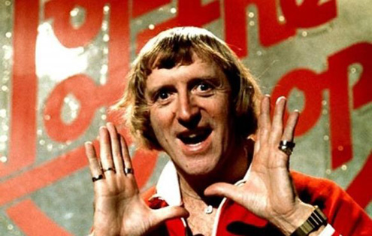](http://media.edusites.co.uk/warehouse/images/operationyewtree/jimmy-savile-top-of-the-pops-1000w.jpg)](http://media.edusites.co.uk/warehouse/images/operationyewtree/jimmy-savile-top-of-the-pops-1000w.jpg)**click on image to enlarge**

Operation Yewtree is a Police investigation, led by London’s Metropolitan Police into alleged sexual abuse, predominantly of minors that commenced on October 2012. It started after enquiries were made following the death of Sir Jimmy Savile on October 2011, a year earlier and expanded to include other high profile celebrities, mainly accused of similar offences in 1960s, into the 1970s and for some of the accused the 1980s – literally hundreds of allegations of child abuse and rape were disclosed leading the Police to believe that Savile was a predatory, prolific sex offender. Initially 589 victims came forward of whom 450 alleged abuse by Savile although as of writing in late August 2013, this is a fluid figure.

This resource seeks to provide a context for the investigation but focusing on how the media has represented the event/events and issue of sexual abuse linking with key texts, primarily Tabloid news media and television news and studying notions of representation of institution, primarily the BBC.

The catalyst for Operation Yewtree was an ITV documentary, ***Exposure: The Other Side of Jimmy Savile*** broadcast on 3rd October 2012. The programme had been researched in depth, over a period of a year by former Police Detective and Presenter, Mark Williams-Thomas. Williams-Thomas is a well-known Child Protection Specialist who has successfully moved from work as a serving Police Officer to media personality. According to his website he is “in demand as a speaker” and is an “award winning investigative reporter with two Royal Television Society Awards, a Broadcasting Press Guild Award and an International Peabody Award”: <http://www.williams-thomas.co.uk/>.

During the documentary Williams-Thomas identifies his credentials as serving for 12 years in Surrey Police Force and being heavily involved in the arrest and charging of convicted sex abuser, singer/ songwriter/producer Jonathan King in 2001. Ironically King’s first arrest was in 2000 after allegations were made to PR guru, Max Clifford, himself currently under investigation as part of Operation Yewtree – Clifford has been charged with eleven cases of indecent assault from 1966-1985 on girls aged 14-19, his trail date is 4th March 2014. Simon Cowell put up a significant amount of Jonathan King’s bail money but King was convicted for the sexual assault of five teenage boys between 1983 and 1989. ***Exposure: The Other Side of Jimmy Savile*** features interviews by alleged victims of abuse by Savile, interviewed by Williams-Thomas who have come forward, some now in their late 40s and 50s to disclose on camera their distressing experiences.

Williams-Thomas introduces Savile has a celebrity who had raised approximately £40m for a range of charities in his lifetime but who had a darker side that nobody was confident enough to fully explore, in part because of his charitable work but also because they were in fear of his (Savile’s) power and influence. The documentary immediately foregrounds the BBC as the ‘vehicle’ for Savile gaining access to young girls on shows such as ***Top of the Pops*** and ***Clunk Click*** and as such, the BBC as a corporation has been ‘on trial’ as well since and during the programme. The impact on the corporation will be explored later. Five women were used as the basis for the evidence presented, in a number of locations including Jimmy Savile’s dressing room at the BBC, in his tour bus and at and in the grounds of Duncroft Approved School in the 1960s and 1970s. The full documentary can be watched at: <http://www.dailymotion.com/video/xv03is_exposure-the-other-side-of-jimmy-savile-3th-oct-2012-full-documentary-itv_news>.

[Exposure - The Other Side of Jimmy Savile - 3th…](http://www.dailymotion.com/video/xv03is_exposure-the-other-side-of-jimmy-savile-3th-oct-2012-full-documentary-itv_news) *by [GerrardOlympic](http://www.dailymotion.com/GerrardOlympic" \t "_blank)*

[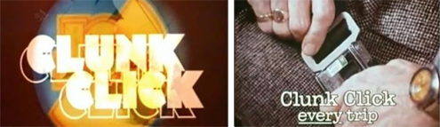](http://media.edusites.co.uk/warehouse/images/operationyewtree/clunk-click-1000w.jpg)**click on image to enlarge**

In the first few minutes of the documentary, Louis Theroux’s 2000, BBC2 documentary***When Louis Met Jimmy*** is referenced <http://vimeo.com/52520464> - an interview is shown from the documentary with Theroux and Savile travelling in the back of a car; Savile is asked why he has said in interviews he hates children to which he replies “it puts the Tabloids off the hunt” but clearly denies that he is a paedophile when Theroux asks about Tabloid newspapers’ obsession over the years about whether he is or is not a sexual abuser.

[When Louis Theroux Met Jimmy Savile | 2000](http://vimeo.com/52520464) from [BY-VIDEO-MALTA](http://vimeo.com/user14403898) on [Vimeo](https://vimeo.com/)

Louis Theroux is a well known documentary maker who gets close to his controversial subjects including boxer Chris Eubank, disgraced Conservative MP Neil Hamilton, Magician Paul Daniels, Puppeteer Keith Harris and Max Clifford and also lives with his subjects during filming. His technique is to befriend the subject and get close enough to draw out revealing admissions and opinion that potentially other more traditional documentary makers would fail to achieve. During the documentary Savile was seen on screen to at times almost develop a friendship and an awkward understanding with Theroux that revealed his (Savile’s) eccentricity, rejection of family life and absolute obsession with his dead Mother who passed away in 1973. In one scene Savile shows Theroux his Mother’s room - immaculate, as if she was still living there with a wardrobe of her clothes that are regularly sent away to be dry-cleaned. Theroux immediately condemned Savile in 2012 once Operation Yewtree revealed the extent of his abuse.

[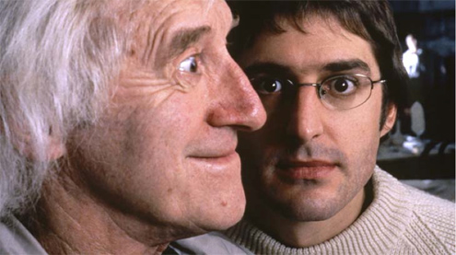](http://media.edusites.co.uk/warehouse/images/operationyewtree/jimmy-and-louis-1000w.jpg)**click on image to enlarge**

Although for many, it is impossible not to realise that “something was clearly not quite right” with Jimmy Savile - only Operation Yewtree revealed the full extent of his ‘darker side’ and has since done the same for convicted BBC Journalist and Presenter Stuart Hall and could potentially reveal the same for a number of other celebrities in what has been described, with differing opinions as the “politically correct cleansing of a rotten decade” (focussing on the 1970s) and as a “witch-hunt, fed by media **moral panics**, hysteria and anxiety”. Williams-Thomas’ documentary starts with witness testimony from BBC employees and then begins to explore events through the testimony of alleged victims. Images of BBC Television Centre are frequently shown with the **narrative voice over** again making regular reference to the corporation. The first alleged victim discusses a 1969 visit to the BBC when she was 15 – invited, with a select group of teenagers into Savile’s dressing room during the recording of ***Top of the Pops***. The interviewee goes on to disclose how she was raped in his tour bus outside King’s Cross station in 1971 during the recording of the BBC’s***Nationwide*** programme.

Williams-Thomas asks ‘Angie’ if she was aware he was going to have sex with him to which she replies, “No”. Williams-Thomas’ motives were never really in doubt in broadcasting the documentary but he was not without detractors, often from the corridors and offices of the BBC. Shortly after the programme he (Williams-Thomas) appeared on BBC Breakfast News and was put on the spot and criticised for trying to get publicity for his next show and in an[anonymous blog](http://www.kingofhits.co.uk/index.php?option=com_kunena&Itemid=65&func=view&id=90289&catid=2) his ability to “state rumour as fact” describing him as a “character assassin” was posited. Williams-Thomas **anchors** his documentary with a well known QC and BBC Journalist and Presenter and founder of the child protection charity, Childline. Ian Glen QC studied the evidence that the documentary presented and states that there is clearly a “pattern of offending” and that there would be “reasonable grounds for arrest” had Savile been alive today.

In a deliberately **emotive** closing piece, Esther Rantzen is shown studying the documentary interview footage and appears to change her opinion of Savile in an instant stating through tears “We all colluded with this”, “He was a God-like figure” and “We all blocked our ears to the gossip” again pointing some of the finger of blame towards the BBC for ‘allowing it to happen’. Savile seemed to have unrestricted access to young girls and because of his charitable work and was allowed to indulge his unusual penchants such as wandering around hospital mortuaries because he liked the feeling of peace being ‘alone with dead people’. The BBC are referenced again in the documentary when Williams-Thomas identifies a 1970s boarding school for ‘troubled teenagers’, Duncroft Approved School where Savile as a fundraiser was invited to raise the profile of the school. It is alleged he abused many of the girls, both in his Rolls Royce and also later when the girls were invited to be part of the audience of the BBC’s ***Clunk Click*** - a programme which gave children the opportunity to meet their idols but also drew its name from the 1971 British government advertising campaign encouraging drivers to wear seatbelts and which starred Jimmy Savile stating the tagline, “clunk clip every trip”.

The show was the precursor of the BBC’s similar show ***Jim’ll Fix It*** (1975-1994) and it is strongly suggested that Savile used the show as an access point to get to young girls, particularly in his dressing room again where “there were no staff around”. The BBC initially rebuked the accusations against Savile stating “no recollection of misconduct could be found” but as Operation Yewtree panned out the corporation had no choice other than state how horrified they were and to agree to fully cooperate with any investigation and to investigate internally themselves – the BBC were at a fundamentally problematical juncture and at this point, the corporation were seen and perhaps wanted to be seen to be almost be engaging in a form of self flagellation as reported by the media. They heaved, lurched and were rocked by one allegation after another involving other celebrities from the 1970s who were connected to the BBC in some way. However, almost a year before Operation Yewtree, two months after Savile’s death, before ITV’s ***Exposure*** documentary and at the absolute beginnings of the increasing drip/river of allegations against Savile the BBC dropped a six week investigation into claims that Savile abused youngsters in December 2011 and ‘shelved their report’.

[](http://media.edusites.co.uk/warehouse/images/operationyewtree/bbc-newsnight-1000w.jpg)**click on image to enlarge**

By the BBC News’ own December 2012 headline, ‘Crisis at the BBC: Timeline of Events’ their involvement and their ‘falling on their sword’ had started<http://www.bbc.co.uk/news/uk-20286848>. George Entwistle replaced Mark Thompson as Director General in September 2012, a month before Williams-Thomas crucial ITV documentary. One day before its broadcast Newsnight Editor Peter Rippon announced in a blog that the programme’s investigation of Savile had been dropped for ‘editorial reasons’.

[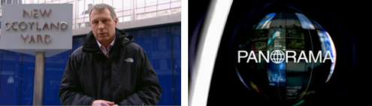](http://media.edusites.co.uk/warehouse/images/operationyewtree/new-scotland-yard-panorama-1000w.jpg)**click on image to enlarge**

Instead, and very clumsily, the BBC aired Jimmy Savile tribute programmes. In an attempt to ‘lock the stable door after the horse had bolted’ new DG Entwistle commissioned a Panorama special, ***Jimmy Savile – What the BBC Knew*** [http://www.youtube.com/watch?v=Qw2zibymtxw](http://media.edusites.co.uk/?URL=http%3A%2F%2Fwww.youtube.com%2Fwatch%3Fv%3DQw2zibymtxw) (part one) to investigate why ***Newsnight*** dropped the investigation and explore more themselves the allegations, not so much to ‘compete’ with ITV but to try and restore confidence in the corporation whose image was being dragged through the mud, along with Savile’s.

<https://www.youtube.com/watch?v=Qw2zibymtxw>

Shortly after a wave of ‘resignations’ commenced, but not before ***Newsnight*** again hit the headlines by wrongly accusing Conservative Peer Lord McAlpine of child abuse leading to an £185,000 out of court settlement, plus costs. In November 2012 George Entwistle resigned, less than two months in post, again causing a mini tidal wave to hit the BBC when MPs investigated that he had been paid, as severance £450,000 which equates to one year’s salary with the inevitable consequences and outcry by TV licence holders, each paying £150-50 per year to watch BBC television (there are nearly 27 million TV licences in the UK which works out to be over £4bn in revenue for the corporation). The BBC have now capped severance and redundancy pay for senior managers. The next resignations were***Newsnight*** Editor and Deputy Editor while separate, internal disciplinary measures began; the BBC were in the spotlight but inevitably, and in a not dissimilar way to its key competition BskyB survived and continues to commercially flourish. The Murdochs (Rupert and James), owners of News Corporation (BskyB and Sky are two of their businesses) went to considerable lengths to protect Sky Television as one of its key assets during the ***News of the World***, News International phone hacking scandal of 2011-12.

The moral panic of paedophilia had now again been ignited by Operation Yewtree, in the same way that the British Tabloid press popularised ‘Sarah’s Law’ calling for parents to have access to a list of convicted paedophiles living in their area. ***The News of the World***ran a ‘name and shame’ campaign publishing the names and photographs of 49 people it said were child sex offenders leading to vigilante groups targeting certain individuals – two men accused of sex offences committed suicide, four innocent families fled their homes in Portsmouth after gossip wrongly identified them as harbouring paedophiles and violence flared in other parts of the country. Media theorists Goode and Ben-Yehuda, in interpreting Stanley Cohen’s 1972 study of youth culture, ***Folk Devils and Moral Panics*** suggested that a moral panic like paedophilia had five distinct stages – concern (generated by the media), hostility (anger is generated), consensus (**binary oppositions** of us and them are drawn out and **hegemonic** representations are circulated and reinforced), disproportionality (over the top reactions e.g. vigilante groups targeting innocent victims) and volatility (the moral panic disappears only to re-appear again at a later date).

It is for this reason that comedian and satirist Chris Morris wrote and starred in the **black comedy** series ***Brass Eye*** (C4 1997 – 2001) that ran a ‘special episode’ called***Paedophilia Special***. It deliberately tackled the post Sarah Payne murder moral panic to illustrate and satirise the media’s knee jerk reaction and hysteria and hypocrisy relating to this subject. [http://www.youtube.com/watch?v=RcU7FaEEzNU](http://media.edusites.co.uk/?URL=http%3A%2F%2Fwww.youtube.com%2Fwatch%3Fv%3DRcU7FaEEzNU) (interpret carefully).

<https://www.youtube.com/watch?v=RcU7FaEEzNU>

Over a decade later the media were awkwardly again raising the subject and profile of paedophilia - on November 8th 2012, live on ITV’s ***This Morning*** presenter Phillip Schofield handed Prime Minister David Cameron a list of names which were alleged to have been mentioned as paedophiles online. Thankfully, and unusually for Cameron he refused to look at the list but uneasily deflected the move by Schofield by stating that he was “worried” that speculation could lead to a witch-hunt, particularly against people “who are gay”[http://www.youtube.com/watch?v=KE1EwKVfh0w](http://media.edusites.co.uk/?URL=http%3A%2F%2Fwww.youtube.com%2Fwatch%3Fv%3DKE1EwKVfh0w). This time, the 1970s as a decade seemed to be on trial.

<https://www.youtube.com/watch?v=KE1EwKVfh0w>

***Giving Victims a Voice*** was a joint Metropolitan Police and NSPCC report published in January 2013 that marked the end of investigations made under the operation regarding Jimmy Savile alone. The public had accepted that Savile was ‘guilty’, his name and reputation had been irrevocably stained, the family had removed his memorial for fear of desecration by vandals and debates about the removal of his ‘Sir’ Jimmy Savile status had been reminded that under current UK law, knighthoods cannot be posthumously removed – now there were other ‘fish to fry’ and the Metropolitan Police set about aggressively responding to further lines of enquiry relating to the sexual abuse of minors by celebrities, mainly during, just before and just after the 1970s - a decade with a social, economic and cultural reputation. The lines of enquiry of alleged abuse were on an unprecedented scale, responding to a huge ‘post Jimmy Savile’ public response.

[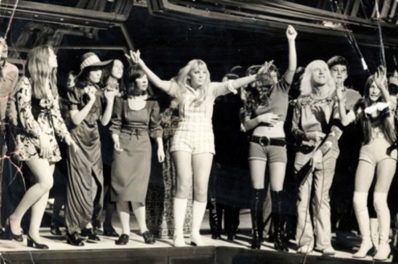](http://media.edusites.co.uk/warehouse/images/operationyewtree/jimmy-savile-1970s-1000w.jpg)**click on image to enlarge**

Paul Gadd (1970s glam rocker Gary Glitter) was arrested again, questioned for 9 hours and bailed on 28th October 2012, days after the commencement of Operation Yewtree. Glitter’s name had become synonymous with sex and minors in Thailand – he had been previously also been found guilty in the UK of having underage pornography on his hard drive and had a reputation to shake off in this regard and was also ‘friends’with Savile. As yet, Glitter has not been charged with the offence stated of having sex with a 13-14 year old girl in Savile’s dressing room. Comedian Freddie Starr was re-arrested on 24th April 2013 over new allegations of molesting a 14 year old girl on Savile’s show ***Clunk Click*** but again, has not been charged as yet. Ex 1970s/80s BBC Radio 1 DJ, Dave Lee Travis (DLT) was arrested after two former BBC employees said he sexually assaulted a number of young women while at the BBC including ‘putting his hand up a 17 year old woman’s skirt’ in 1977 and ‘jiggling a presenter’s breasts’ live on BBC Radio4 in the 1980s. DLT was charged with several counts of indecent or sexual assault on 15th August 2013 as the CPS believed they have enough evidence to prosecute.

The publicist, Max Clifford was also charged on 26th April 2013 with 11 indecent assault charges relating to the period 1965 through to 1985 – as of writing he has pleaded not guilty as Westminster Magistrates Court. Max Clifford is a controversial figure who often himself represents unpopular clients and also works for clients wishing to sell ‘kiss and tell’ stories to the Tabloids. The four other high profile celebrities arrested under Operation Yewtree are Stuart Hall (arrested, charged and currently in prison), Jim Davidson who was arrested on 20th March 2013 (but not charged), Jimmy Tarbuck who was arrested and again not charged over an allegation of sexual assault on a young boy dating back to the 1970s and Rolf Harris who was initially arrested in March 2013 and rearrested on 5th August 2013. The BBC and Jimmy Savile’s Chauffeur, David Smith was also charged with a number of sexual offences, further sullying the reputation of the broadcaster for ‘letting it happen under their nose’.

The case of Stuart Hall was particularly high profile - he had been a media celebrity and presenter for six decades, initially presenting regional news for the BBC in the north-west moving on to present the popular, irreverent British comedy game show, ***It’s a Knockout***(1966-1988), receiving particularly high ratings in the 1970s and broadcast on BBC1. Hall was known for his madcap laugh and enthusiastic, ironic commentary which anchored the show. Later in his career he reported on football for the BBC as a radio commentator but in May 2012, when aged 82 the Police received an anonymous letter via a journalist about historic sexual offences involving prepubescent and adolescent girls. After initially denying any wrongdoing he pleaded guilty to indecently assaulting 13 girls aged between 9 and 17 years old between 1967 and 1986. Obviously a body blow for Hall it was yet another attack on the BBC who immediately terminated his contract and announced yet anther inquiry into his conduct while at the corporation. On 17th June 2013, Hall was sentenced to 15 months in prison but following the sentencing the Attorney General’s office received complaints that the sentence was lenient and as a result, his sentence has been increased to 30 months. Further allegations of sexual assault against Hall, including the alleged rape of a 12 year old girl are currently being investigated.

Many rumours accompanied the charging and sentencing of Stuart Hall. This was to be the first Operation Yewtree ‘imprisonment’ and as such was seen as a template for potential further cases. He was very popular in the wider community and had been appointed OBE in the 2012 New Year Honours for his services to broadcasting and charity which it is said, prompted one of his alleged victims to come forward in disgust – in 1999 various MPs signed a House of Commons motion congratulating Hall on 40 years in broadcasting. On first sentencing a further allegation was said to have been ‘kept on the court’s file’, implying only some form of agreement had been made but as identified above, further investigations are current after continued media coverage and it is unclear whether this one allegation is part of it. Hall’s defence stated during the trial that the amount and extent of Stuart Hall’s alleged abuse (13 victims) was wholly disproportionate to the regularity and extent of the abuse Jimmy Savile was accused of over a sustained period. Hall’s alleged abuse of young women was described as ‘isolated incidents’. Barrister Barbara Hewson provoked further controversy writing for ***Spiked*** magazine arguing that many of Hall’s sex offences such as fondling a 17 year olds breasts or kissing a 13 year old girl were low “low level misdemeanours” (***Spiked*** is an online magazine focusing on politics, culture and society) and takes a liberal, humanitarian approach with its predecessor being ***Living Marxism***. Hall transferred his property worth £1.2m into his wife’s name in February 2013 it is alleged to avoid 17 civil claims against him and the BBC seeking justice and compensation.

[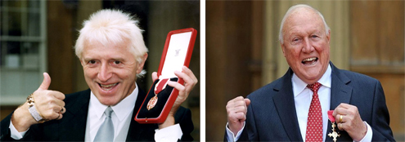](http://media.edusites.co.uk/warehouse/images/operationyewtree/jimmy-savile-stuart-hall-obe-1000w.jpg)**click on image to enlarge**

Operation Yewtree has surprised the public and although some celebrities that have been named as part of the investigation would be less shocking to some, some named suspects are. Many people are wondering where the investigation is going and how many more people will be arrested and questioned after further allegations and how many more 1970s**icons** will be in prison in a year’s time. Privately the BBC must wonder what has hit them, the Metropolitan Police have been direct, decisive (rightly or wrongly) and have needed to be seen to be swift to act in a climate of anxiety. There also seems to have been a cultural aspect in terms of reaction to the investigation with some older members of the public acknowledging the wrongdoings but implying “that’s what happened, that’s what the 1970s were like” which rightly has enraged victims who have been brave enough to come forward after all this time – in the same way that a young girl from Duncroft Approved School who refused Jimmy Savile’s advances was put ‘in solitary’ for two days, many victims of abuse at the time feared nobody would listen to them. Other cultural commentators have suggested that the alleged abusers have had a similar approach to abusing power and control and many of them were in fact ‘Thatcherite’ in their ideological beliefs. Like Mick Philpott (see[case study](http://media.edusites.co.uk/article/wjec-as-media-studies-ms1-representation-of-events-the-philpott-tragedy/)) they thought they were invincible and could get away with anything. The media arguable made Mick Philpott, all of the celebrities that have been interviewed would be considered to be powerful, wealthy, influential individuals.

The BBC, Kudos produced crime drama ***Life on Mars*** (2006-2007) set in 1973, initially co-created and written by Tony Jordan introduced audiences to the character of Gene Hunt played by Philip Glenister. Gene Hunt was based on Jack Regan from the violent 1970s Police Drama ***The Sweeney*** – Hunt was deeply sexist and disrespectful to women, openly racist, chain smoked and drunk whisky at work, was corrupt and regularly broke the rules to get a conviction, swore and regularly came out with one liners which have become the stuff of legends on websites.

<http://www.telegraph.co.uk/culture/tvandradio/7497633/10-best-Gene-Hunt-quotes.html>

Audiences warmed to his old fashioned 1970 persona and led them to cite nostalgia as one of the key appeals for the programme; nostalgia for an era when the Police were corrupt and abused their power, were openly sexist and saw women as sex objects, were abusive towards suspects and had virtually no barriers or boundaries to what they could or couldn’t do – as represented by the programme. Yes, this is **popular culture** and crime fiction but based on sociological fact. One could be forgiven for suggesting the same erroneous behaviour has been allegedly mirrored by Operation Yewtree suspects.

[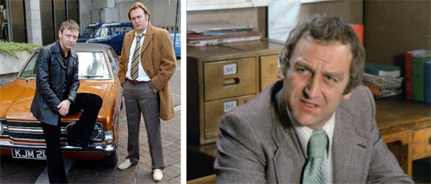](http://media.edusites.co.uk/warehouse/images/operationyewtree/popular-culture-crime-fiction-sociological-fact-1000w.jpg)**click on image to enlarge**

## **Mini Glossary**

* **Moral Panics**: Where the media regularly discusses an issue, often creating fear and anxiety.
* **Narrative Voice Over**: First person commentary normally by the central protagonist or in this case, documentary maker.
* **Iconic**: Well know, famous or infamous.
* **Anchors**: Makes something definite.
* **Emotive**: Something that uses emotion to gain a certain representation.
* **Hegemonic Representation**: Representations that are traditional, old fashioned and represented as common sense.
* **Binary Oppositions**: Two things that are very different, placed next to each other to create meaning.
* **Black Comedy**: Difficult humour that explores taboo subjects.
* **Ideology**: An overarching set of ideas and beliefs that are often used as a form of political or social control.