WJEC AS Media Studies MS1 Representation of Events | The Philpott Tragedy 11th May 2012
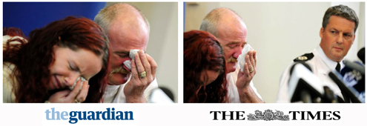click on image to enlarge
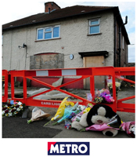
On 11th May 2012, Jade, John, Jack, Jesse and Jayden Philpott were killed in a house fire at 18 Victory Road, Allenton, Derby. Their half-brother Duwayne Philpott died in hospital three days later – all children were aged between 5 and 13.
The fire was started by their father, Mick Philpott and his accomplice Paul Mosley in an attempt to frame his ex-girlfriend Lisa Willis who had recently left him, and to gain custody of their children.
It went tragically wrong but not before Mick Philpott and his wife Mairead on 16th May held an emotional news conference describing the events of that day – one of the investigating officers went on record after they were convicted stating that when he was caught by a television camera staring at the grieving Mick Philpott it was because he suspected his involvement in the fire.
Mick Philpott and his wife Mairead Philpott were arrested on 28th May 2012, just 12 days after the news conference and charged with murder on 30th May and held on remand. On 5th November 2012 Mick Philpott’s accomplice, Paul Mosley was also charged with the same offence but later the offence of all three (murder) was downgraded to manslaughter as it was decided they (the Philpott’s and Mosley) had not intended to kill the children. While on remand at the time for the murder, the funerals of the children took place on 22nd June which the Philpott’s were prevented from attending and by 12th February 2013 their trial had started at Nottingham Crown Court. On April 4th Mick Phipott was convicted of manslaughter and sentenced to life imprisonment with a tariff that he serve a minimum of 15 years, his wife and Mosley were sentenced to 17 years of which they will serve at least half before their release on licence.
By the time of the trial, a significant media event had turned into a media circus with regular reporting in all forms of media, particularly high impact formats television news and newspapers, specifically the tabloids and mid-market tabloids. Newspapers and television had been running reports on the tragic story since the 12th May and this resource seeks to track the media response of this event from the day after the crime to the media fall-out following conviction and sentencing and also the media coverage of Mick Philpott prior to the fire and how this was mediated to audiences during the case.
Mick Philpott had become a minor celebrity in 2006 – just like a fading star he allowed himself to be manipulated by a hungry media keen on reinforcing cultural stereotypes to sell newspapers and entertain their target audiences. Right wing moral panics are historically commonplace and long before the endless tabloid and mid-market tabloid headlines of 2012 and 2013 Mick Philpott appeared on The Jeremy Kyle Show in 2007 after a series of tabloid headlines criticised him for daring to request a larger council house. As the story goes, Mick Philpott appeared on the show ‘to defend himself’ whereas what actually happened was that his representation was carefully mediated to audiences on the show to create the conflict that this daytime ITV tabloid chat show relies on.
https://www.youtube.com/watch?v=1e1waM9T7b8
The Jeremy Kyle Show thrives on the bullish, arrogant, hyper real representation of its anchor and in placing Philpott on the show it was an ideal vehicle for masculine conflict between two stereotypical alpha males – one in a position of power publicly as a revered,iconic presenter (the American equivalent of Jerry Springer) and the other in a position of power privately as the patriarchal head of a family which included two women living with him under the same roof, both sharing his bed and sharing his children by them both. Feminist critiques of Jeremy Kyle have been apparent but on this particular show, two egotistical males presented audiences with the form of entertaining vulgarity that brings high ratings. At one point Philpott asks Kyle to ‘talk to his elbow’ and Kyle responds by simply raising his voice and shouting at him from his centre stage vantage point in front of his loyal studio audience.
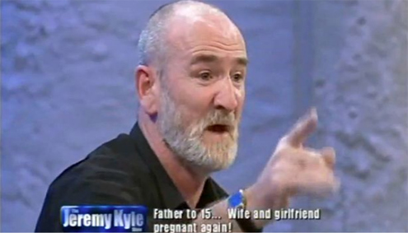
As is often the case, the form of ‘bear bating’ used in this television genre had the same effect as the appearance of many participants in Reality TV shows which was to construct asecondary persona through what by now was print and audio visual exposure. The tabloid media had spawned a monster and Philpott just ran with it. His undoubted enjoyment at being on television was clearly apparent in exchanges with Kyle and the studio audience and fed the flames of his ego to the point that he probably thought he was invincible and untouchable. However, his representation was also of mutual benefit to the mainstream, mass media who were able to also develop yet another extreme stereotype to use for commercial gain and also to maintain dominant culture – working class, unemployed was bad, hard working employed good.
Philpott’s journey into the world of the tabloid media continued into August 2007 when again ITV1 invited him to spend a week with a former outspoken Conservative minister Ann Widdecombe in a documentary entitled Ann Widdecombe versus the Benefits Culture. The programme and subject was again ideal for the stereotypically working class, opinionated C2, D and E ITV1 staple target audience who would enjoy the distinct binary opposition between an elderly, socially conservative, Catholic, traditional Widdecombe who lists bringing back the death penalty and opposing the legality of abortion with the working class as priorites with Philpott. Philpott was represented as a northern (he lived in the Midlands), rough, patriarchal ‘benefits scrounger’ with a history of violence against women (he is once alleged to have fired a crossbow into his girlfriend’s leg because he didn’t like what she was wearing).
Like The Jeremy Kyle Show it was tabloid heaven with two characters that were more alike than either would ever dare admit – Widdecombe had for some time also allowed herself to become a television celebrity with appearances and guest presenting on a number of shows that exploited her own eccentric but ‘loveable’ secondary persona; like Boris Johnson she was a ‘funny Tory’. In the documentary audiences witnessed two characters that were deliberately placed in opposition to create a preferred meaning. Throughout the documentary Widdecombe was fiercely critical of his lifestyle and spend most of the time trying to persuade Philpott to change his lifestyle, refusing to live on his premises for the week and decamping instead to a nearby hotel. Philpott was seen to enjoy immensely the attention that his second television appearance gave him and was as combative with Widdecombe as she was with him.
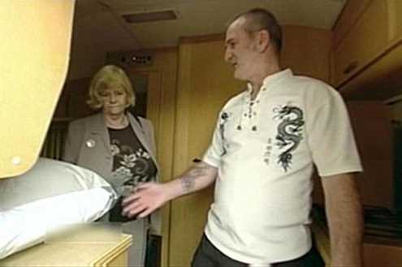click on image to enlarge
Predictably there was no narrative closure, certainly no mutual respect but without doubt ‘job satisfaction’ that ITV1 had produced another tabloid piece of television attracting advertising revenue allowing viewers a form of voyeuristic audience identification. Significantly missing from recent (April 2013) ‘Philpott coverage’ is that the media made him, or at least allowed him to develop further an already overblown sense of his own identity but ensuring that, thanks to ITV1 there are people out there who are interested in what he has to say. The media is of course is in no sense to blame for what happened in May 2012 but must be seen as shamelessly exploiting a representation and news story for purposes of entertainment and ideology. When Mick Philpott set fire to his home I am certain he was convinced he could ‘get away with it’ as he was fuelled with a disproportionate sense of self.
Immediately post the 11th May tragedy the media immediately recognised Philpott as if he was ‘one of their own’ – like he was Jade Goody or Amy Winehouse and waited patiently for the Police to charge him and his wife before unleashing an ideological barrage of vitriol mostly reflecting their own political news values. The image at the beginning of this resource suggests that even before they were represented as suspects many were doubting the story Philpott concocted but the media had to wait. The officer in question staring at Mick Philpott was proudly trotted out in a number of documentaries stating that he knew he was guilty long before the judiciary could prove it. The media often represent this form of theatre and have a formulaic approach to representing grieving families appealing to the public to the point that sadly for relatives using this form of communication it has become just another form of voyeuristic scrutiny, an intrusion into grief. The ‘toothless’ PCC have received a significant number of complaints over the years about the representation of Kate and Jerry McCann but this time the media got the ‘green light’ as soon as the Police arrested the Philpott’s and haven’t looked back since.
The Daily Mail ran with the headline “VILE PRODUCT OF WELFARE UK” with even George Osborne jumping on board linking Mick Philpott’s chronic unemployment with his crime – a shameless opportunity to, like the media to exploit a representation and a story. Osborne and the Tory party saw the event as an opportunity to state a case for the reforms of the welfare system in the UK. The floodgates opened and the tabloids called ‘open season’ on a series of scathing attacks on the background of Mick Philpott, conveniently forgetting that he was perfect for them in 2006 and 2007, selling newspapers and maintaining daytime TV ratings but most importantly almost bypassing the tragic event in favour of using the opportunity to encode their own ideology.
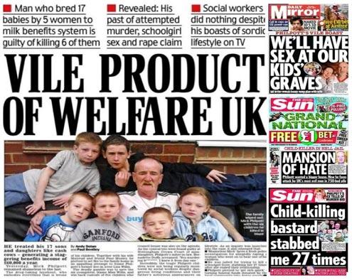click on image to enlarge
The Guardian, predictably responded offering their own left wing challenge to The Daily Mail (main header above) and The Sun et al by reminding viewers on its website that benefits are also given to people in work – “it’s not just the unemployed who receive benefits….if the welfare system is to blame why has this sort of tragedy not happened before?” Previous to this The Daily Mail had reinforced their headline story with the subheading “The 190 families with 10 children cost you £11m a year” encoding an inclusive, direct mode of address that is their house style with repeated use of the word ‘you’ creating the myth of a personal form of communication.
The Quietus, an online music magazine, known for its liberal ideologies supported The Guardian’s response to The Daily Mail by reminding their readers that “last year more than 1100 people died after their incapacity benefit was rescinded….....Mick Philpott’s crimes are being used to provide cover” (8/4/13). The Philpott Tragedy, as an event had now become a political pawn, for both the government, tabloid editors and journalists who saw an opportunity to develop their opinions, values and beliefs on the back of such a terrible occurrence. The Huffington Post, a liberal American online website/blog (see below) also covered the event from a political perspective, using the opportunity to lambast The Daily Mail for using the story to develop a Welfare State narrative that of course a left wing website like The Huffington Post is going to be in binary opposition to. The site offers a UK version which is highly interactive, exploiting the potential of web 2.0 and the ‘blogosphere’ to reach audiences of a like mind in terms of their political views.
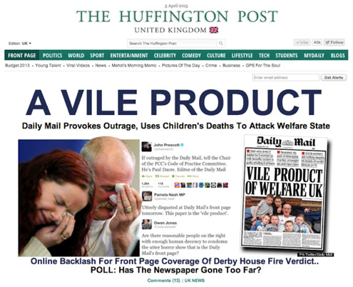click on image to enlarge
Gendered readings also dominated media coverage with the idea of polyamory frequently referenced as a more voyeuristic approach to covering the story – polyamory describes Mick Philpott’s personal circumstances involving his cohabitation with two women, both of whom he had accepted sexual relations with. Some media represented Philpott as the ultimate patriarch whose control over women was such that they feared him and complied with his every wish. His history of violence was apparent and his ‘choice’ of women ensured that he could exploit their vulnerability. In any other circumstance that did not involve the death of six children the media would have exploited more this representation as dominant / preferred or oppositional readings. Certainly before the tragedy and duringThe Jeremy Kyle Show in 2007 his hyper real, alpha male persona was utilised as a point of reference for audiences who either felt a deep hatred for him (hate is a key emotion generated by Kyle) or harboured an almost latent aspiration for his potentially Marxist individualism – he rejected the capitalist rule of law and chose instead an anti establishment, avant-garde pathway that involved using the state to fund his and his families’ lifestyle. Ann Widdecombe, as representative of the state failed to ‘bring him down’ in her subsequent documentary probably feeding his own ideological perspective on what is wrong and right.
The vitriol has continued up to the present day with newspapers, after his incarceration seeking to continue to sell copy based on this running story in the same way that the McCanns have sold newspapers since Madelaine McCann’s disappearance on 3rd May 2007. Emotive representations are a staple of newspapers and television news as audiences empathise, sympathise or simply hate. On April 3rd 2013 The Mirror online stated “Six kids killed in fire started by twisted dad to finally get headstones” while a few days later ran with the story “Mick Philpott placed on hit list by gypsies who want him tortured”. One is reminded that a year earlier the same and other newspapers were ‘persecuting’ Basildon gypsies who were being evicted finally from Dale Farm, representing them as a scourge and a blight to the life of honest Essex folk. Now they were the tabloids friend and morality barometer.
The Daily Mail online declared on 10th April 2013 “Surviving son of Mick Philpott vows to change his name” while more local media to the event, The Derby Telegraph wrote “I hate Mick Philpott, he’s dead to me know” in reference to his 14 year old son. At some point, news stories about this event will dry up, in the same way fall out after the death of Margaret Thatcher is slowly fading and in the same way the saturation coverage of the 2012 Olympics did – the media will always hold on tight to any event that allows them to feed a hungry audience with a range of narrative interpretations and readings, always underpinned by commercial gain.

Mini Glossary of Terms
- Media Circus: A frenzy of media coverage.
- Mid Market Tabloid: Using the conventions of a broadsheet and a tabloid.
- Mediated: Selected and constructed for audiences.
- Cultural Stereotypes: Where individuals or social groups are given homogenous (all the same) characteristics, as represented in the media.
- Moral Panics: Where the media regularly discusses an issue, often creating fear and anxiety.
- Hyper Real Representation: Exaggerated representations for purposes of entertainment.
- Iconic: Well know, famous or infamous.
- Patriarchal: Male domination.
- Secondary Persona: A personality / representation that is built up in media coverage.
- Dominant Culture: Whatever culture is seen to be ‘ruling’ or preferential.
- Binary Oppositions: Two things that are very different, placed next to each other to create meaning.
- Narrative Closure: A story with a conclusion.
- Voyeuristic: The pleasure of looking at other people.
- Ideology: An overarching set of ideas and beliefs that are often used as a form of political or social control.
- Encode: Put meaning in (decode takes meaning out).
- Mode of Address: The way a media text speaks to its audience.
- House Style: A common pattern found in media (repeated often to encode brand identity).
- Web 2.0: Interactive online media, e.g. social networking.
- Dominant and Oppositional Readings: Where audiences either decode what has been intended or a completing different interpretation.

