WJEC AS Media Studies Representation of Issues: Immigration
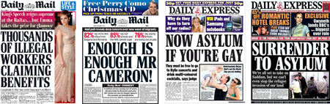click on image to enlarge
Immigration is a rich representation topic for WJEC AS Media Studies because it can allow us to explore ethnicity, nationality, events and issues simultaneously. It can be quite a sensitive topic in the classroom, so it is important that students understand some of the key terminology that is often misinterpreted or conflated in the Media.
- Immigration: Coming to live in a country different to your birth-place.
- Immigrant: Someone arriving in a country (other than their place of birth) hoping to live there.
- Emigrate: To leave one’s country of birth to take residency in another country.
- Migrant: Someone who moves from one place to another.
- Economic Migrant: Someone who moves to a country specifically for financial reasons - in order to improve their standard of living.
- Illegal Immigrant: Someone who moves to a country without the correct paperwork, i.e. Visas and a work permit. They are often smuggled into a country in terrible conditions in an attempt to escape problems in their home country. This group of people are often the most exploited.
- Asylum Seeker: Someone who has fled his or her home country as a political refugee and is seeking refugee status in another place. They are often kept in holding camps while the Home Office considered their case and while here have limited rights including not being able to work.
Often all of these terms are conflated in the press identifying people who are not White British, or anyone who is ‘new’ to the UK as an ‘Other’ by identifying them as “immigrant” or “second/ third-generation immigrant”. Such construction of Otherness is used to createbinary opposites in news narratives.

History of Immigration in the UK
Immigration is not a new topic, however it is continuously perpetuated as a problem by the national press who provoke mass hysteria and moral panics about immigration, particularly at times when there is social crisis, i.e. recession.
After World War Two, immigration was celebrated in the UK. The “Empire Windrush” was the first ship of Commonwealth migrants to arrive after the war, in 1948, and marked the start of an immigration boom. This action was embraced by the national press at the time because the migrants were needed to help rebuild the post-war nation.
We can see in this Evening Standard front cover from the time that the new arrivals were called the “400 sons of the Empire” thus they were attributed with a sameness - they are familiar; part of our Empire, just like us.
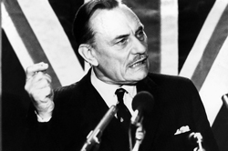
The headline: “Welcome Home!” Also suggests that these people belong in England. This encourages the reader to have a positive attitude towards immigration. However, not everyone has celebrated immigration. Conservative MP Enoch Powell famously delivered his “Rivers of Blood” speech in 1968 condemning the increasing numbers of “Other” people arriving in the UK. The controversy of his words however, saw him dismissed from his position in parliament. Though in 1962, the Conservative Government’s Commonwealth Immigrants Act had already tightened regulations on the number of Commonwealth residents who could enter the UK.
https://www.youtube.com/watch?v=mw4vMZDItQo

Another consequence of the war was the development of the pan-European government the European Union which was created with the aim of uniting the continent through shared legislation, free trade and free movement across borders. The expansion of the European Union has often been a heated topic of debate in the UK Media because a larger EU means there is the potential for more European immigration. The expansion of the European Union since 2004 has led to numerous ex-Soviet Bloc countries becoming members. Many of these countries were deeply impoverished by the Soviet rule and after the fall of Communism, many national newspapers have focused on newer members from Eastern European in their stories about economic migrants particularly with the recent increase in the privileges of newest members Bulgaria and Romania.

Immigration in Today’s Media

Immigration Event: The ‘Romania-Bulgaria’ Moral Panic
When Bulgaria and Romania joined the EU in 2007, nationals were allowed to travel to the UK without a visa but there were restrictions on the type of work they could get; they had to apply for special work permits in order to work in the UK and were not entitled to job seekers’ allowance or other benefits. However, in-keeping with EU agreements from January 1st, 2014, these restrictions were lifted and Romanians and Bulgarians can now work and claim the same benefits as other EU citizens freely.
Despite the fact there were already thousands of people from both countries already working in the UK (thanks to the work permit scheme), the right-wing national press turned January 1st into a moral panic. Stanley Cohen coined the term moral panic in response to the treatment of particular youth cultures, particularly the ‘Mods’ and ‘Rockers’ by the press in the 1960s. He identified that these groups were demonised. We say a moral panic is created when the Media identifies a scapegoat for a social problem that the control culture(or ruling class) cannot fix. The scapegoats are demonised by the Media and blamed for the issue through sensationalisation tactics and scare mongering. We can see this pattern in relation to the EU restriction lift as follows:
Step 1: The social problem - Britain is just emerging from its worst recession and unemployment rates are still incredibly high (according to HRM it is 7.1%).
Step 2: The identification of scapegoats ¬ - If work restrictions are being lifted to allow more Romanians and Bulgarians to come to the UK this could make the job market even harder for the 7.1% unemployed already in the country because there will be more people applying for jobs. If these people don’t find work then they can now claim benefits, “funded” by those who work.
Step 3: The demonisation - Romanian and Bulgarian citizens are represented as “benefit scroungers”, “beggars” and as “stealing our jobs”.
Step 4: Finally, the public are called to protest against the restrictions as if this might solve the current unemployment crisis.
The MailOnline hyperbolised the problem with sensationalist headlines and sub-headings which gave the impression that there would be a flood of immigrants suddenly arriving at UK borders on New Year’s Day.
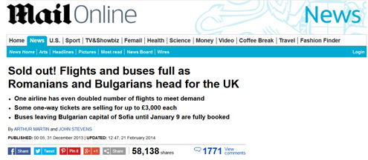click on image to enlarge
Once might except flights and buses in any country to be “fully booked” over the holiday period, however by including reference to the “UK” in the headline, the MailOnline here conflates a number of travel issues to exaggerate the number of migrants who might be arriving in the UK in January, 2014: 1) Sold Out! Flights and buses, 2) An increase in services over the holiday period, 3) An increase in ticket prices for last minute holiday travel (or illegal ticket touting). None of the statements specifically refer to travel to the UK, but the use of the word “as” in the headline insinuates a link between the sold out travel options and migration to Britain.
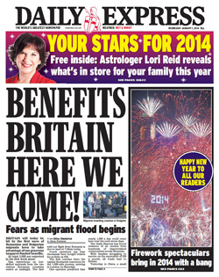
In another article from The Daily Express (full article available here) the story makes front page news on New Year’s Day. The sensationalism of the headline is reinforced by the threatening use of direct address(“here we come!”) and alliterationwhich adds force to the phrase (“Benefits Britain”). The alliteration also serves as a “nickname” for Britain which has connotations of victimhood and weakness expressing the notion that these people -the “Others” see us as feeble and are going to invade. The juxtaposition of the story next to the beautiful, colourful depiction of the New Year’s Eve firework display over London sets up a binary opposite of peace and conflict, yet the fireworks also signify a tension and add to the atmosphere of invasion. There is a certain similarity to the rhythm of “Benefits Britain” and “Battle of Britain” which is reinforced by the image of London’s horizon ablaze.
The article then opens with: “BRITAIN will today be hit by the first wave of Romanian and Bulgarian migrants keen to take advantage of our generous taxpayer- funded benefits”.
In the standfirst, the newspaper uses emotive language to encourage the reader to agree with their point-of-view. The word “Will” ensures the reader thinks this is definitively going to happen rather than speculation. “Take advantage” and “generous taxpayer-funded benefits” set up a binary opposite between “us” - who are all the same (taxpayers) and “them” - the strange “Others” who will take money from us. The newspaper glorifies its reader by referring to them as “our generous taxpayer(s)”, implying they have a great level of respect for them (which these new arrivals will not!). The use of “first wave” is significant too because it suggests that this will be a repeated trend. The image of “waves” of course conjures up the idea of a constant stream of Romanians and Bulgarians appearing at our borders.
This article exemplifies a common trend in the right-wing press about this event -the conflation of “Romania” with “Roma culture”. The Roma people are one of the largest travelling communities in Europe, often derogatively referred to as “gypsies”. While a large number of Romas live in Romanian, it is not the largest collective in Europe. The words “traveller” and “gypsy” are often given negative connotations in the Media, stereotypicallyassociated with “invading” local land, causing a nuisance and increased crime rates. The journalist’s choice to focus here on “Jilava, a small Roma town outside Bucharest” instantly homogenises the perceived “gypsy problem” with the “Romanian immigration problem” therefore doubling the impact of the story and further sensationalising it. If we consider adeviance scale with the white, male, upper class at the top, travelling communities are one of the most negatively perceived groups in society. Eastern Europeans, such as Romanians would be considered slightly more favourably, but their Soviet history still sees them marked as “Other” in most narratives - from Bond films to newspapers.
Another persuasive element to this story is the use of first person quotations from Romanian people, who state: Britain is a “rich country and people get more help from the state to support children; that is something we expect there… Britain is a different world, a different life to us. There the powers have the power to live, so it’s paradise…”
These quotes reinforce the mythic image of Britain as the Dick Whittington country, where the streets are paved with gold -this is a myth perpetuated by right-wing British media, to encourage separatist views of Britain and fuelled by historic British imperialism. In the spirit of ethical journalism, it is likely that the subjects interviewed did say this, but there is little balance in the article to the point-of-view of other people planning to migrate.
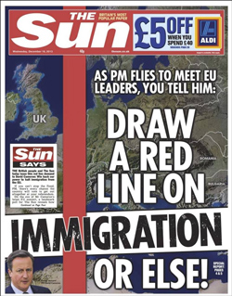
We see the final step of the moral panic about Romanian and Bulgarian immigration illustrated clearly in the right-wing tabloid newspaper The Sun.
The dominance of the English red and white colours that strike through the background image of Europe clearly separate the UK from the continental mainland. This image has a strongnationalist message. The phrase “you tell him” instigates that it is the reader who calls for Prime Minster David Cameron to take action against the potential risk of immigration. Also the capitalisation of the headline and it’s ending with “or else!” is threatening. This front page assumes the reader already believes the lift on work restrictions for Romanians and Bulgarians to be a serious problem and therefore calls them to react. The inclusion of a tiny image of David Cameron in the bottom, left corner represents him as weak -as someone dominated by Europe, but also as someone who the readers can rally against.
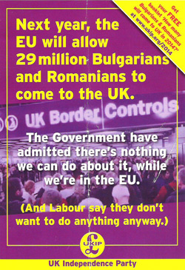
To the far extreme of the right-wing media, we have UKIP (the UK Independence Party) propagandaadvertising. The background image of the poster denotes a busy day at one of the UK’s airports, however due to theanchorage of the text, in this context the image symbolises the chaos that Bulgarian and Romanian immigration will cause. The use of numbers (“29 million”) gives the falsification of facts which helps to persuade the audience to believe in the sensationalist claim - the poster is likely to provoke panic at the thought of 29 million extra people in the UK (when in fact this numbers equals the populations of Bulgaria and Romania combined and it is highly unlikely that everyone in both countries is going to migrate to the UK in 2014).
The repetition of the word “we” gives an inclusive feel to the poster, giving the reader a sense of belonging to the party: this is a common tactic used in propaganda. The layout of the copy cleverly constructs a Todorovian narrative structure - a dis-equilibrium is expressed: the 29 million Bulgarians and Romanians, then antagonists are introduced - “The Government” and “Labour” who won’t solve the problem. Finally, at the bottom centre of the poster, a re-equilibrium is proposed: “The UK Independence Party”. The party as solution to the problem is highlighted through repetition in the logo, the name and the colour scheme. This poster was used as part of UKIP’s 2013 pre-election campaign, where they received more votes than ever before. The campaign highly offended Bulgarian officials - read more on the debate here.
In contrast to the right-wing anti-immigration stance, the left-wing Media did all it could to debunk the moral panic. In the Independent (15th January 2014) the headline read: “UK immigration: Fewer than 30 Romanian arrivals since border restrictions lifted, says country’s ambassador to Britain”.
As the story which you can read in full here continues, it is clear that the “fewer 30 Romanian arrivals” is just an estimate by the ambassador. By not including the word “estimate” in the headline, the Independent appears to claim this is a fact (the use of numbers always helps persuade people that they are reading evidence rather than assumptions, therefore it is important for newspapers to write them numerically in headlines). Rather than state a specific number lower than 30, the newspaper uses the word “fewer” which again serves as a counter-argument to the exaggerated high numbers in the right-wing press. The word implies there are not only “fewer” than 30 people, but “fewer” than expected thus it serves to expose the moral panic perpetuated by its rival newspapers.
In a less subtle story The Guardian (3rd January, 2014) openly accuses the right-wing Media of causing a moral panic with this headline: “Bulgarian and Romanian immigration hysteria “fanned by far-right”. Former Bulgarian foreign minister says talk of surge of eastern Europeans into UK is politically motivated and highly unlikely”.
Though the sub-heading implies the headline words are the thoughts of a former Bulgarian minster, the point-of-view is not established in the headline, thus also establishing the statement as part of the newspaper’s ideology.
In contrast to the busy image of a chaotic border control on the UKIP poster, the image below was used in an article about Jon Danzig (read here) an investigative journalist and blogger, to illustrate the right-wing hysteria. The lone figure framed as dominant element in the image, surrounded by emptiness as he walks through an airport is constructed as a binary opposite to the right-wing images of huge numbers of migrants arriving in the UK. Of course, just as the UKIP image was taken out of context, this image is also heavily constructed.
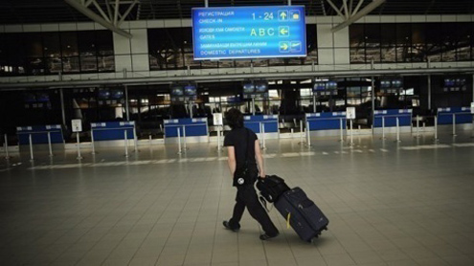click on image to enlarge
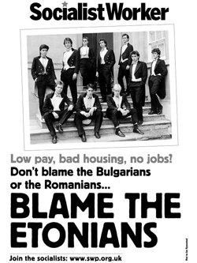
In a counter-government campaign, but to the other extreme to UKIP, The Socialist Worker produced the campaign image below. The use of a simple monotone colour scheme signifies that the answer is simple, as the poster says it’s the “Etonians” fault not the Bulgarians or Romanians. Just like the UKIP poster it offers anotherthree act structure through the layout of the copy: first - the situation: “low pay, bad housing, no jobs?” Then proposed antagonists (but the false ones!) “The Bulgarians and the Romanians”. Finally, we find re-equilibrium if we “blame the Etonians” -this statement is celebrated as a finale to the story through its capitalisation. An epilogue is added “Join the socialists” as a call to action to encourage the reader that this is the only way to fight those who are to blame.
The grouping of those in government through their school photograph and the collective noun “Etonians” labels them as the “Other” rather than the migrants blamed in the Media texts we have already explored.

The Home Office “Go Home” Campaign
Another recent story that hit the UK news was the creation of the government’s information advertising campaign to encourage illegal immigrants to go home.
The use of strong yellow blocks as background to the writing adds a threatening menace to the posters as they draw the attention of passers-by. The main copy on both adverts directly addresses the audience and implies potential guilt through the use of a rhetoric question.
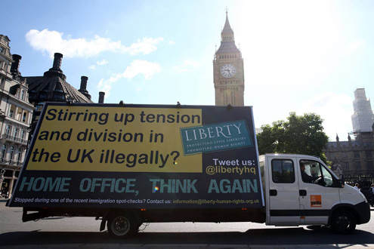click on image to enlarge
The decision to create these as moving adverts, which patrol neighbourhoods adds a sense of surveillance - as if the driver and the advert are spying on your activities. This adds a further threatening feel to the campaign. Finally, the second advert uses a large image of a handcuff (with no person caught by it so presumable waiting for YOU!) and the tagline “106 arrest last week in your area” to further intimidate the audience. These adverts caused a huge backlash, with the hashtag “#RacistVan” trending on twitter.
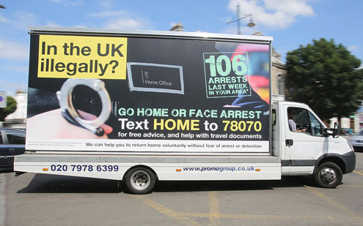click on image to enlarge
The Advertising Standards Authority received more than 200 complaints regarding the adverts, most of which focused on 5 issues:
- The poster, and in particular the phrase “GO HOME”, was offensive and distressing, because it was reminiscent of slogans used by racist groups to attack immigrants in the past.
- The poster was irresponsible and harmful, because it could incite or exacerbate racial hatred and tensions in multicultural communities.
- Several complainants challenged whether the claim “106 ARRESTS LAST WEEK IN YOUR AREA” were misleading and could be substantiated.
- A few complainants challenged whether the qualification in the small print was presented clearly, because it was not legible on a moving vehicle.
- A few complainants challenged whether the poster was misleading, because it implied that arrest was the automatic consequence of remaining in the UK without permission.
Issue 3 and 4 were upheld by the authority and the pilot campaign was withdrawn by the Home Office. For the full ASA complaints report see here.

Mini Glossary
- Other/ Otherness: A media construction when a person, place or social group is constructed as different from the norm established by the ruling class’s dominant ideology.
- Sameness: When people or places are described with similar features or as a collective in order to establish that they are ideologically united, i.e. “on the same side”.
- Binary Opposite: Polar opposites used in narratives to set-up antagonism.
- Narrative: The way in which a story is told.
- Ruling Class: Those whose ideas are the dominant ideology - the people who control the media and government of a culture.
- Dominant Ideology: The values and beliefs of the ruling class generally considered to be the “norm” or “common sense”.
- Mass Hysteria: When the Media provokes panic over an issue or event through sensationalisation.
- Moral Panic: The construction of scapegoats for a social problem in the Media.
- Headline: The large title text of a newspaper story.
- Right Wing: Conservative, nationalist, and to the extreme, Neo-Nazi ideologies.
- Left Wing: Liberal, socialist and, to the extreme, communist ideologies.
- Demonise: To construct a negative image of a person, place or social group so as to blame them for a social problem.
- Scapegoat: The demonised person, place or social group who are usually not at fault at all, but are highlighted as trouble makers by the Media.
- Control Culture: The ruling class.
- Sensationalistion: The process of exaggerating something in the press.
- Scare Mongering: Encouraging hatred or negative feelings towards a person, place or social group.
- Hyperbole: An exaggeration.
- Front Page News: Something considered newsworthy enough to make the front page is usually considered to be the most important story of the day.
- Direct Address: A linguistic techniques where the producer of a text speaks to the audience, using personal pronouns to create a personal relationship between author and audience.
- Alliteration: The repetition of the starting sound of a word in the next word.
- Standfirst: The opening paragraph of a news story which usually includes the most important information.
- Emotive Language: Language which is designed to provoke an emotional response from the audience rather than to deliver information.
- Point Of View: The perspective from which the audience is supposed to relate to a media text. Point-of-view is always constructed by the producer.
- Connotation: The meaning we can take from a text.
- Stereotype: A generalisation about a person, place or social group.
- Deviance Scale: A concept which suggest the ruling class always look at “Others” on a scale, tarring some social groups as enemies, nuisances or deviants (those whose values conflict with their own) and others to be allies (who mostly agree with their values, or who can be manipulated to agree).
- Persuasive Techniques: Literary, visual and aural codes used by producers to persuade audiences to buy into their values.
- First Person Quotation: The use of quotes from people who have a vested interest or knowledge about a subject, presented in a news story. These are usually used to give the impression that the story is factual as the people are symbolised as “witnesses” and their words as “evidence”.
- Myth: In Media Studies, myth is the constructed ideological value of a culture.
- British Imperialism: Refers to the days of the British Empire, but Britain ruled over several countries across the globe and was seen as one of the dominant powers in the world.
- Nationalist: A far right political persuasion that is anti-EU and anti-immigration, this perspective believes that UK traditions and values are of the utmost importance.
- Propaganda: Usually political advertising which aims to persuade audiences to believe in specific values.
- Denotation: The literal meaning of a media text.
- Anchorage: When one element, i.e. the text helps to give a closed meaning to another - an image, which might otherwise be interpreted in many different ways.
- Todorovoian Narrative Structure: Todorov was a narratologist who identified three acts (in some Media Studies text books 4 acts) to narrative structures: equilibrium (the status quo), dis-equilibrium (a problem which creates a quest) and re-equilibrium (the re-establishment of the status quo or peace) or Equilibrium, Disruption, Resolution and New Equilibrium.
- Antagonists: Characters or issues which attempt to prevent a quest from being fulfilled.
- Repetition: A persuasive technique which keeps a particular idea in audience’s heads.
- Framing: The positioning of objects in a layout or images to create specific meaning.
- Dominant Element: The main focal point of an image.
- Copy: The written element of a media text.
- Epilogue: An aside, or extra element, that comes after a finale.
- Call To Action: An advertising technique which encourages the audience to do something.
- Information Advertising Campaign: Advertisements designed to inform the audience about a serious issue rather than to sell them something.
- Rhetorical Question: A persuasive technique used to encourage the audience to response (Though of course they can’t literally response to the advert).
- Tagline: A persuasive phrase on an advert which is usually catchy and written in such a way that the audience will remember it and relate it to the brand.
- Advertising Standards Authority: The organisation responsible for monitoring the advertising industry and ensuring that adverts are not misleading and are “legal, honest and truthful”.

